

**Programming Method**

**Module Title**

**Air Pollution**

**DYNAMIC WEBSITES**

**Assignment Title**

**Spring 2020**

**Examination Cycle**

**PYAE THUTA**

**Candidate Name**

**00185308**

**Candidate No**

**KMD Institute (Yangon)**

**Centre Name**

**31 January 2020**

**Submission Date:**

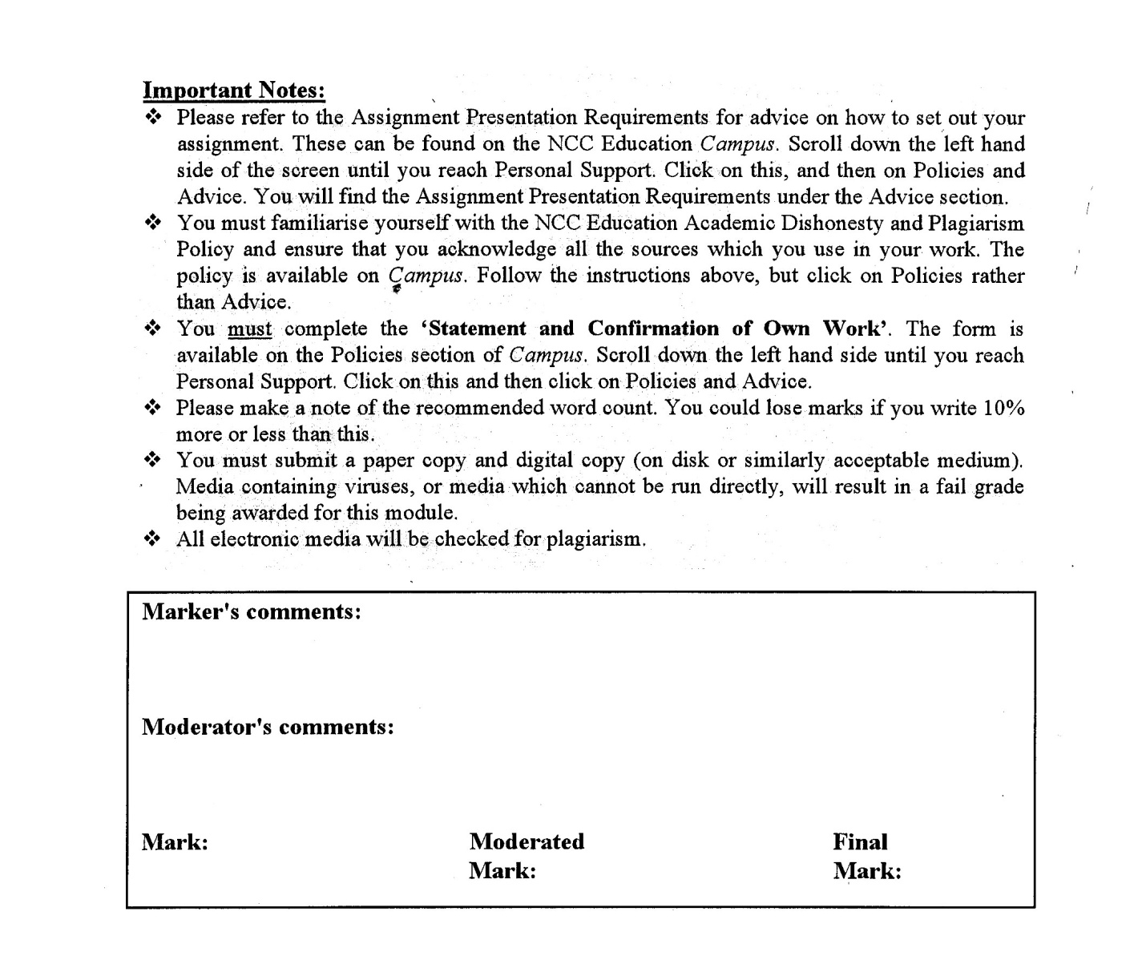



**Statement and Confirmation of Own Work**

**Programmed/Qualification Name: L5DC**

*All NCC Education assessed assignments submitted by students must have this statement as the cover page or it will not be accepted for marking. Please ensure that this statement is either firmly attached to the cover of the assignment or electronically inserted into the front of the assignment.*

**Student declaration**

I have read and understood NCC Education’s Policy on Academic Dishonesty and Plagiarism.

I can confirm the following details:

**Student ID/Registration number : 00185308**

**Name : PYAE THUTA   
Centre Name : KMD Institute (Yangon)**

**Module Name : DYNAMIC WEBSITES  
Module Leader : SHAIN THU  
Number of words : [1685] words**

I confirm that this is my own work and that I have not plagiarised any part of it. I have also noted the assessment criteria and pass mark for assignments.

**Due Date : 31 January 2020  
Student Signature : thuta**

**Submitted Date : 31 January 2020**

**Table of Content**

Contents

Introduction 4

**Analysis** 6

**Assumption** 6

**Class Diagram** 7

**Database Design** 8

**Screen Design** 12

**Coding** 15

**Testing** 21

**Analysis** 35

**Assumption** 35

**Screen Design** 36

**Coding** 38

**Testing** 50

**Analysis** 70

**Assumption** 70

**Screen Design** 71

**Coding** 72

Task 4 79

**Assumption** 80

**Testing** 85

Task 5 95

**Analysis** 96

**Assumption** 96

Task 6 102

**Evaluation** 103

References 104

Candidate Checklist 105

# Introduction

Air pollution is becoming more dangerous year by year effecting humans’ health in both long-term and short-term. It mainly causes diseases such as lung and heart conditions, problems of breathing and sensitivity to pollution. A website providing information about air pollution has been asked to be created. The website must include information about air pollution levels in a country now and in past.

The dynamic website should include the facts that meets the user requirements. It should include background video and a fluid layout. The website must be responsive in all different devices. The social media buttons or navigation buttons should have animation when accessing them.

Users must be able to create their personal accounts. The system needs to store all the personal details of every registered user. The website should allow users to create, browse and edit their own information. User must be able to log in to their accounts and do functions such as viewing their accounts, updating their information and changing their password. These all should be done on a database.

A search engine optimization should be included. The responsive landing page should include compelling headline, eye-catching images, two media links to other pollution websites, call action buttons for sign-up. The website must contain an offer for free home pollution testing kit to customers.

This website must be created with the use of PHP, MySQL and JavaScript. A web service that show the purchases made should also be made.

Task 1

## **Analysis**

**Task (1)** is to create a landing page or home page for the website. That landing page should include compelling caption against a clean colorful backdrop. The information provided must be displayed clearly on a clean and colorful background. This landing page should also include images which can attract users. A scroll-triggered animations must be included in that landing page. A background video must be automatically loading in the page for user attraction. The information displayed should be in the fluid layout clearly. Social media buttons must be animated and should be included in the landing page. The information should have at least (2) media links to relevant pollution websites. At least one call to action button for sign up must also be included.

## **Assumption**

The landing page have three sections displaying information about what is air pollution, causes of air pollution, air pollution in a city by years and how to solve pollution problems. Each sections are displayed systematically on the landing page with relevant captions and guide for being easy to use and navigate. For the background color, pale lavender color is chosen. The information is displayed clearly using black font color so that users can read easily. There are many eye-catching images with captions and information about them. These captions and images are landed in the fluid layout which are responsive to different devices. A scroll-trigger button will appear at the button-left corner of the landing page when users scroll the page more than 1000px in height. When users click on that button, the page will auto scroll to the top smoothly. A background video showing information about air pollution all over the world is auto loading at the top of the landing page with a caption on it. There are social media buttons with the icons of Facebook, twitter, Instagram and You Tube in the footer section. Some header are linked to related air pollution websites. Under the background video, there is an about us button. When users click on that button, a modal box displaying information about website will be appeared including an animated call to action button. When the user hover over the sign up button at the navigation bar, a form displaying a free home pollution testing kit offer will be shown. All these functions are written with the use of PHP, CSS and Java Script.

## **Class Diagram**



## **Database Design**

|  |  |  |  |
| --- | --- | --- | --- |
| File Name: user  Primary Key : userid  Foreign Key : none | | | |
| **Field Name** | **Type** | **Field Size** | **Description** |
| userid | INTEGER | - | Unique ID for user in integer datatype. |
| username | VARCHAR | 30 | Name of user |
| email | VARCHAR | 30 | Email of user |
| dob | DATE | - | User’s date of birth |
| gender | VARCHAR | 20 | Gender of users |
| postaladdress | VARCHAR | 255 | User’s postal address for delivering |
| postcode | INTEGER | - | Postal code of users |
| password | Text | - | Encrypted password |

|  |  |  |  |
| --- | --- | --- | --- |
| File Name: staff  Primary Key : staffid  Foreign Key : none | | | |
| **Field Name** | **Type** | **Field Size** | **Description** |
| staffid | INTEGER | - | Unique ID for staff in integer datatype. |
| staffname | VARCHAR | 30 | Name of staff |
| email | VARCHAR | 30 | Email of staff |
| gender | VARCHAR | 20 | Gender of staff |
| password | Text | - | Encrypted password |

|  |  |  |  |
| --- | --- | --- | --- |
| File Name: product  Primary Key : productid  Foreign Key : none | | | |
| **Field Name** | **Type** | **Field Size** | **Description** |
| productid | INTEGE | - | Unique ID for product in integer datatype. |
| productname | VARCHAR | 50 | Name of staff |
| description | Text | - | Description for the product |
| price | INTEGER | - | Price of the product |
| photo | Text | - | File path of the product image. |

|  |  |  |  |  |
| --- | --- | --- | --- | --- |
| File Name: history  Primary Key : historyid  Foreign Key : userid | | | | |
| **Field Name** | **Type** | **Field Size** | **Description** |
| historyid | INTEGER | - | Unique ID for history in integer datatype. |
| historydate | DATE | - | Date that the history is done |
| userid | INTEGER | - | Unique ID for user |
| PageName | TEXT | - | Name of webpage. |

|  |  |  |  |  |
| --- | --- | --- | --- | --- |
| File Name: question  Primary Key : questionid  Foreign Key : userid  : staffid | | | | |
| **Field Name** | **Type** | **Field Size** | **Description** |
| questionid | INTEGER | - | Unique ID for question in integer datatype. |
| questiondate | DATE | - | Date that the question is asked. |
| userid | INTEGER | - | Unique ID for user. |
| staffid | INTEGER | - | Unique ID for staff. |
| ansdate | DATE | - | Date that the answer is submitted. |
| answer | TEXT | - | Replied answer by staffs. |
| question | TEXT | - | Asked question by users. |

|  |  |  |  |  |
| --- | --- | --- | --- | --- |
| File Name: purchase  Primary Key : purchaseid  Foreign Key : userid  : productid | | | | |
| **Field Name** | **Type** | **Field Size** | **Description** |
| purchaseid | INTEGER | - | Unique ID for purchase in integer datatype. |
| purchasedate | DATE | - | Date that the purchase is made. |
| userid | INTEGER | - | Unique ID for user who purchase the product. |
| productid | INTEGER | - | Unique ID for staff which user purchases. |
| quantity | INTEGER | - | Quantity of product purchased. |
| totalprice | INTEGER | - | Total price. |

## **Screen Design**

**Main.php**

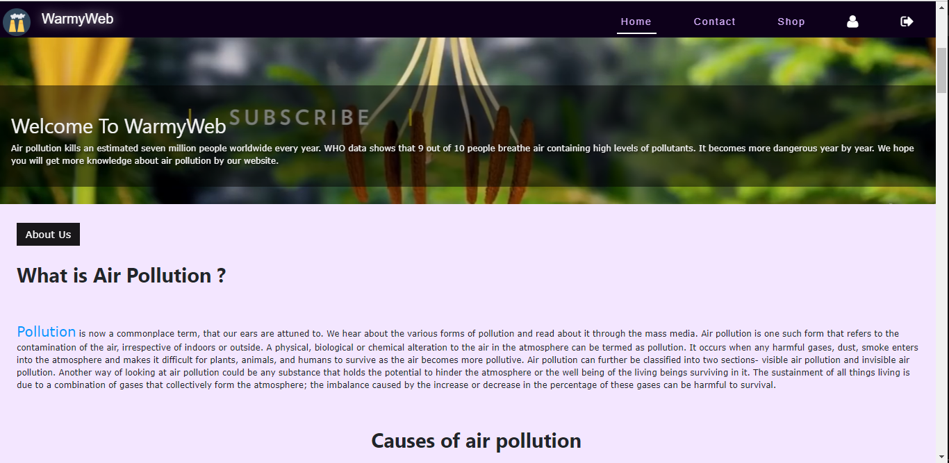

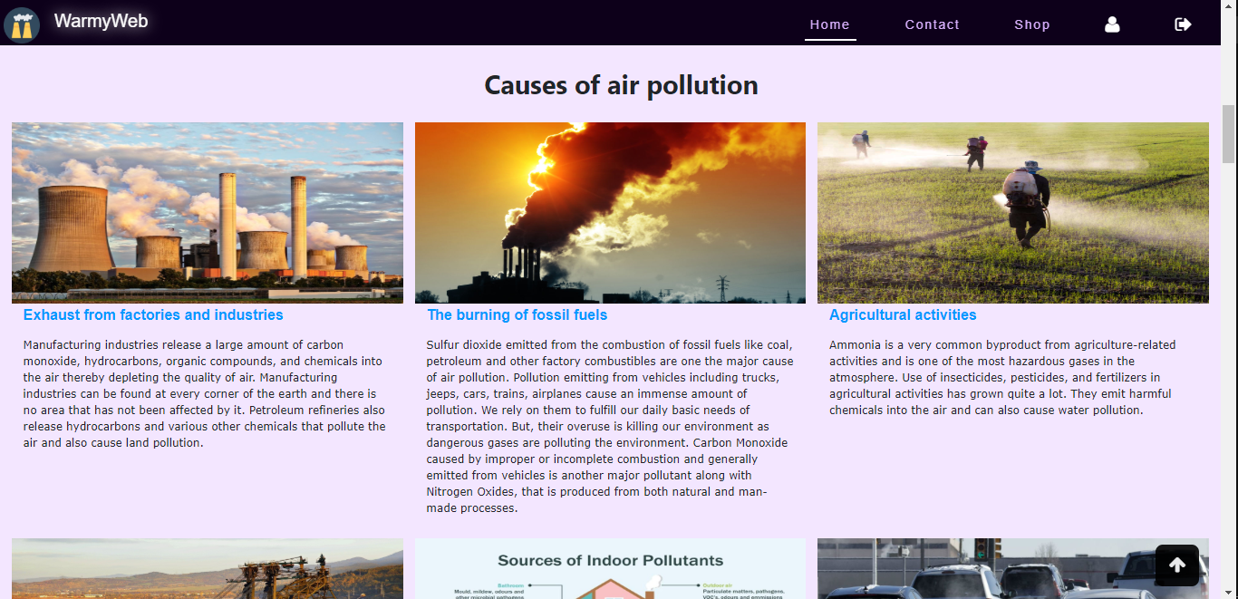

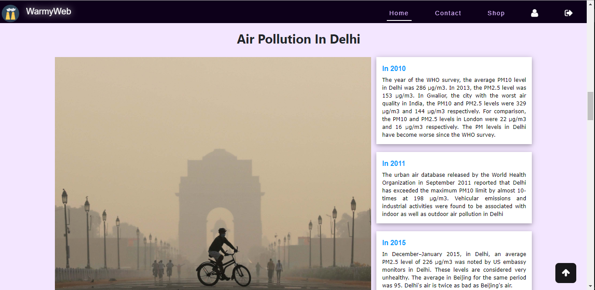

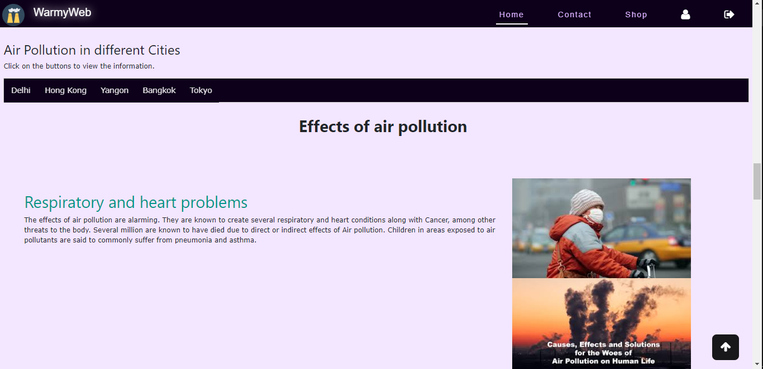 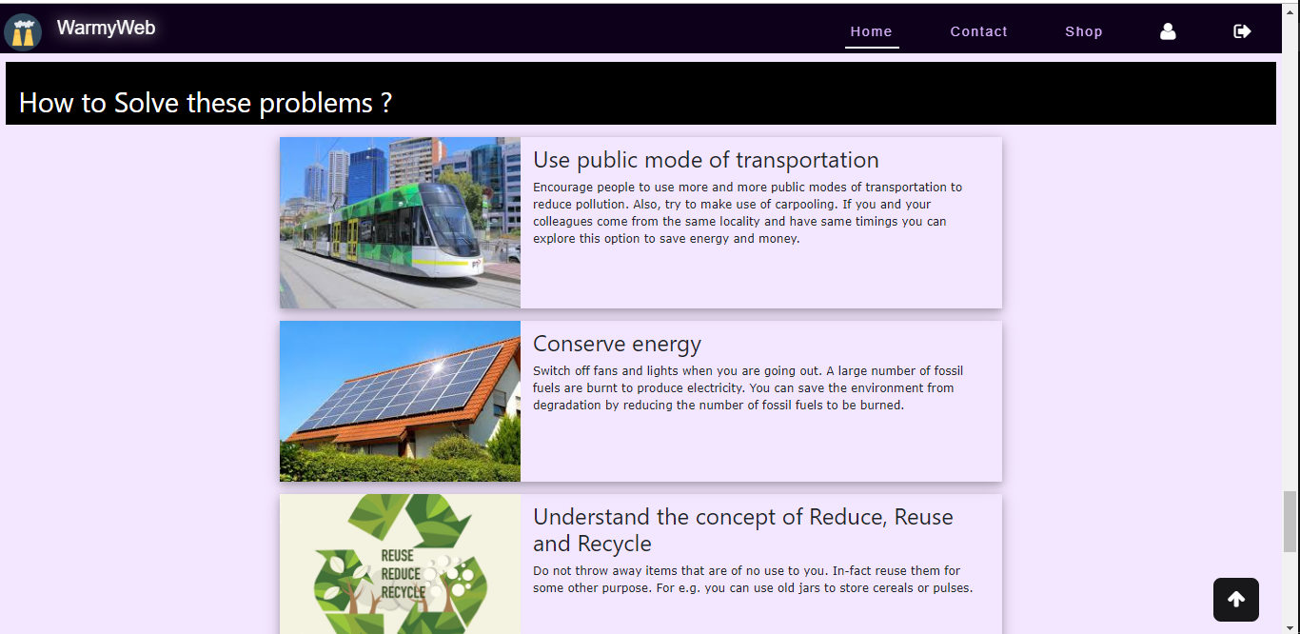

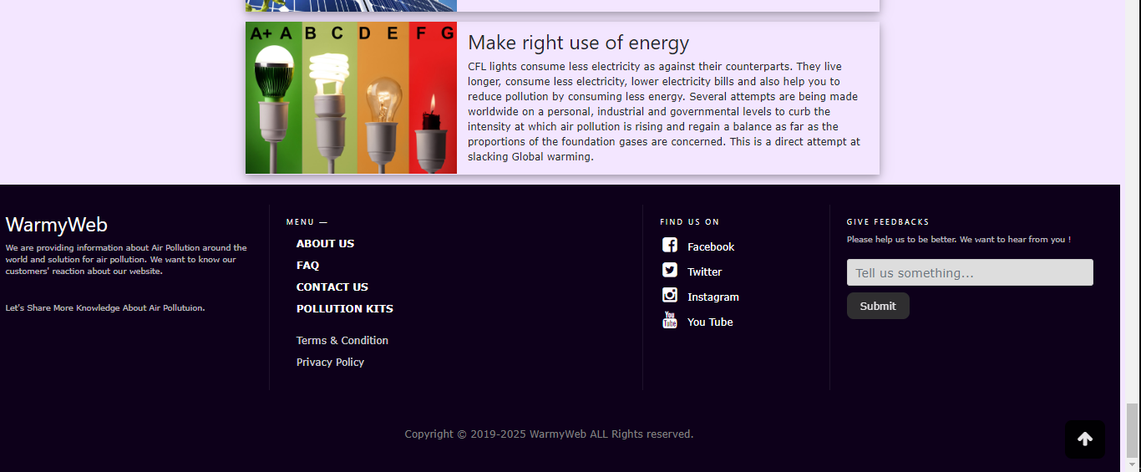

## **Coding**

**setup.php**

<?php

$connect = mysqli_connect('localhost', 'root','', 'airpollutionDB');

$drop1 = "DROP TABLE Question";

$run = mysqli_query($connect, $drop1);

$drop2 = "DROP TABLE history";

$run = mysqli_query($connect, $drop2);

$drop3 = "DROP TABLE purchase";

$run = mysqli_query($connect, $drop3);

$drop4 = "DROP TABLE staff";

$run = mysqli_query($connect, $drop4);

$drop5 = "DROP TABLE user";

$run = mysqli_query($connect, $drop5);

$drop6 = "DROP TABLE product";

$run = mysqli_query($connect, $drop6);

$create = "

CREATE TABLE user

(

userid INT Auto_Increment NOT NULL PRIMARY KEY,

username VARCHAR(30),

email VARCHAR(30),

dob DATE,

gender VARCHAR(20),

postaladdress VARCHAR(255),

postcode Int,

password TEXT

)

";

$run = mysqli_query($connect, $create);

if ($run)

{

echo " Customer Table Created<br>";

}

else

{

echo mysqli_error($connect);

}

// Insert -----------------

$insert = "INSERT INTO User VALUES (1, 'Pyae', 'pyaethuta881@gmail.com', '2002/11/11', 'Male', 'Thingangyun', 255692, 'pass')";

$run = mysqli_query($connect, $insert);

if ($run)

{

echo "Data Inserted<br>";

}

else

{echo mysqli_error($connect);}

// --------- STAFF

$create = "

CREATE TABLE Staff

(

staffid INT Auto_Increment NOT NULL PRIMARY KEY,

staffname VARCHAR(30),

email VARCHAR(30),

gender VARCHAR(20),

password TEXT

)

";

$run = mysqli_query($connect, $create);

if ($run)

{

echo " Staff Table Created<br>";

}

else

{

echo mysqli_error($connect);

}

// Insert -----------------

$insert = "INSERT INTO Staff VALUES (1, 'Pyae', 'pyaethuta881@gmail.com', 'Male', 'pass')";

$run = mysqli_query($connect, $insert);

if ($run)

{

echo " Staff Data Inserted<br>";

}

else

{

echo mysqli_error($connect);

}

// ---------- Question

$create = "

CREATE TABLE Question

(

questionid INT Auto_Increment NOT NULL PRIMARY KEY,

qdate date,

question text,

userid INT,

staffid INT,

ansdate date,

answer text,

FOREIGN KEY (staffid) REFERENCES Staff(staffid),

FOREIGN KEY (userid) REFERENCES user(userid)

)

";

$run = mysqli_query($connect, $create);

if ($run)

{

echo " Question Table Created<br>";

}

else

{

echo mysqli_error($connect);

}

$insert = "INSERT INTO Question VALUES (1, '2019/12/12', 'What is pollution ?', 1, 1, '2019/12/24', 'Pollution is trending problem all over the world')";

$run = mysqli_query($connect, $insert);

if ($run)

{

echo "Question Data Inserted<br>";

}

else

{

echo mysqli_error($connect);

}

// ---------- History

$create = "

CREATE TABLE history

(

historyid INT Auto_Increment NOT NULL PRIMARY KEY,

historydate VARCHAR(30),

userid INT,

PageName text,

FOREIGN KEY (userid) REFERENCES user(userid)

)

";

$run = mysqli_query($connect, $create);

if ($run)

{

echo " History Table Created<br>";

}

else

{

echo mysqli_error($connect);

}

// Insert -----------------

$insert = "INSERT INTO history VALUES (1, '2002/11/11', 1, 'Question')";

$run = mysqli_query($connect, $insert);

if ($run)

{

echo "Data Inserted<br>";

}

else

{

echo mysqli_error($connect);

}

// ---------- Product

$create = "

CREATE TABLE product

(

productid INT Auto_Increment NOT NULL PRIMARY KEY,

productname VARCHAR(50),

description text,

price int,

photo text

)

";

$run = mysqli_query($connect, $create);

if ($run)

{

echo " Product Table Created<br>";

}

else

{

echo mysqli_error($connect);

}

// Insert -----------------

$insert = "INSERT INTO product VALUES (1, 'Air Quality Tester', 'Black LED Display Rechargeable Large Capacity Accurate Air Quality Pollution Monitor Meter PM2.5 Detector for Home Office', '31.4', 'media/kit1.jpg')";

$run = mysqli_query($connect, $insert);

if ($run)

{

echo "Data Inserted<br>";

}

else

{

echo mysqli_error($connect);

}

// ---------- Purchase

$create = "

CREATE TABLE purchase

(

purchaseid INT Auto_Increment NOT NULL PRIMARY KEY,

purchasedate Date,

productid int,

userid int,

FOREIGN KEY (productid) REFERENCES product(productid),

FOREIGN KEY (userid) REFERENCES user(userid)

) ";

$run = mysqli_query($connect, $create);

if ($run)

{

echo " Purchase Table Created <br>";

}

else

{

echo mysqli_error($connect);

}

// Insert -----------

$insert = "INSERT INTO purchase VALUES (1, '2020-1-4', 1, 1)";

$run = mysqli_query($connect, $insert);

if ($run)

{

echo "Data Inserted<br>";

}

else

{

echo mysqli_error($connect);

}

?>

## **Testing**

**Test Case 1**

|  |  |
| --- | --- |
| Test objective | Test Database Can be Created or Not in MySQL |
| Test Data | Database name= “airpollutiondb” |
| Test Procedure | Give the database name and enter create button |
| Expected Result | Show success message to user |
| Actual Result | See Fig (1, 2) |

**Before Testing**

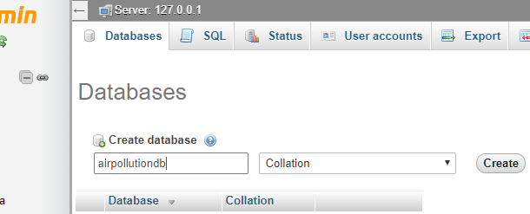

Fig (1)

**After Testing**

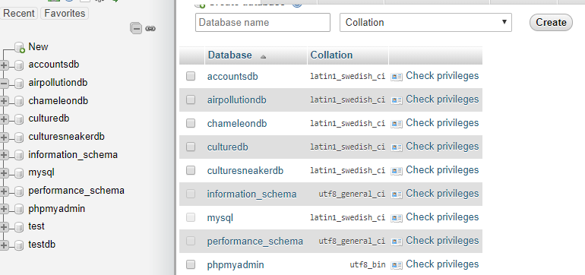

Fig (2)

* **Compelling caption against a clean colorful backdrop**

**Test case 2**

|  |  |
| --- | --- |
| Test objective | Compelling caption against a clean colorful background |
| Test Data |  |
| Test Procedure | Check captions in the main page. |
| Expected Result | Compelling caption against a clean colorful background is shown. |
| Actual Result | See Fig (2.1) |

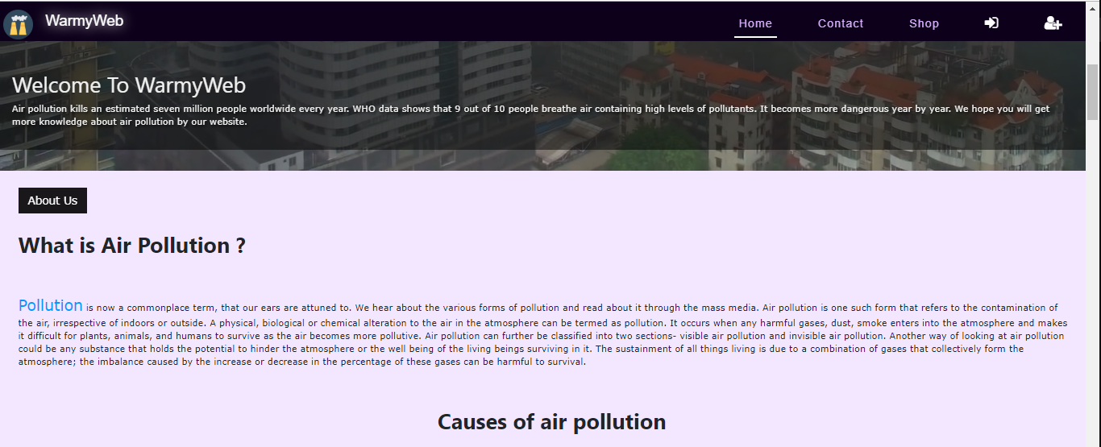

**Fig (2.1)**

The caption and information are written with black font color in the pale lavender background so that users can see the information clearly.

* **Clean Colorful backdrop**

**Test case 3**

|  |  |
| --- | --- |
| Test objective | Clean colorful background |
| Test Data |  |
| Test Procedure | Check background in the main page. |
| Expected Result | Clean colorful background is shwon |
| Actual Result | See Fig (3.1) |



**Fig (3.1)**

* **Eye-catching images**

**Test case 4**

|  |  |
| --- | --- |
| Test objective | Testing if eye-catching images contain in main page. |
| Test Data |  |
| Test Procedure | Check images in main page. |
| Expected Result | Eye-catching images are shown. |
| Actual Result | See Fig (4.1, 4.2) |

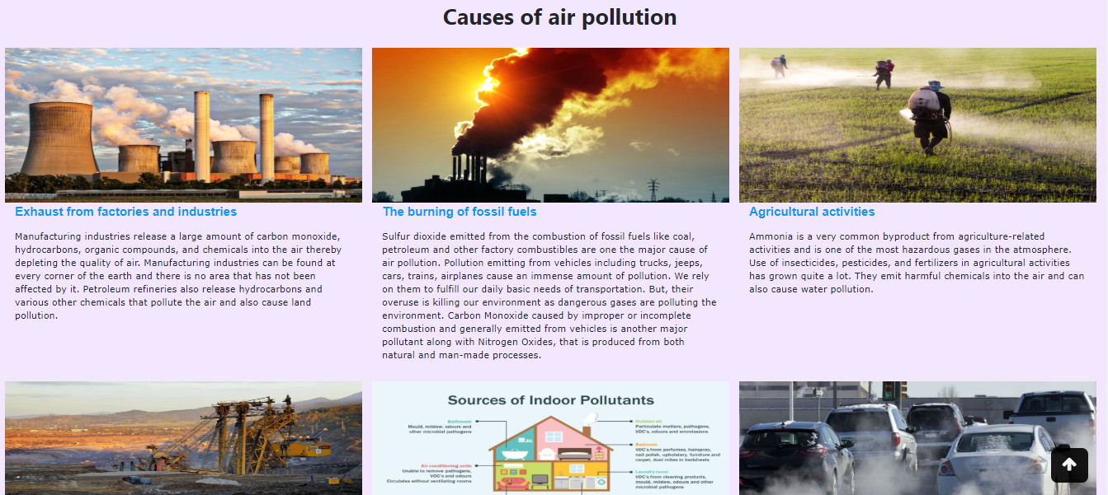

**Fig (4.1)**

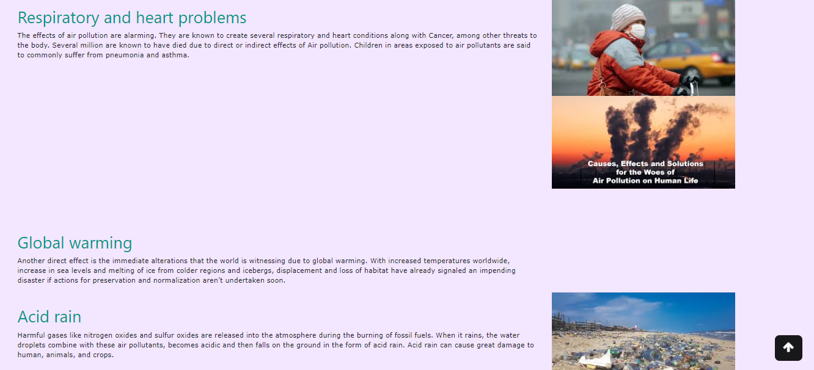

**Fig (4.2)**

There are eye-catching images with relevant captions and information.

* **Scroll-triggered animations**

**Test case 5**

|  |  |
| --- | --- |
| Test objective | Testing if the top of the page is reached if user click on the scroll to top button. |
| Test Data |  |
| Test Procedure | Click on go to top button. |
| Expected Result | Top of the page is reached. |
| Actual Result | See Fig (5.1, 5.2) |



**Fig (5.1)**



**Fig (5.2)**

A scroll-triggered button will appear when user scroll down the page which will scroll to top of the page on click.

* **Automatically loading background video**

**Test case 6**

|  |  |
| --- | --- |
| Test objective | Testing if automatically loading background video is contain in the main page. |
| Test Data |  |
| Test Procedure | Check the background video in main page. |
| Expected Result | A background video is auto loading. |
| Actual Result | See Fig (6.1) |

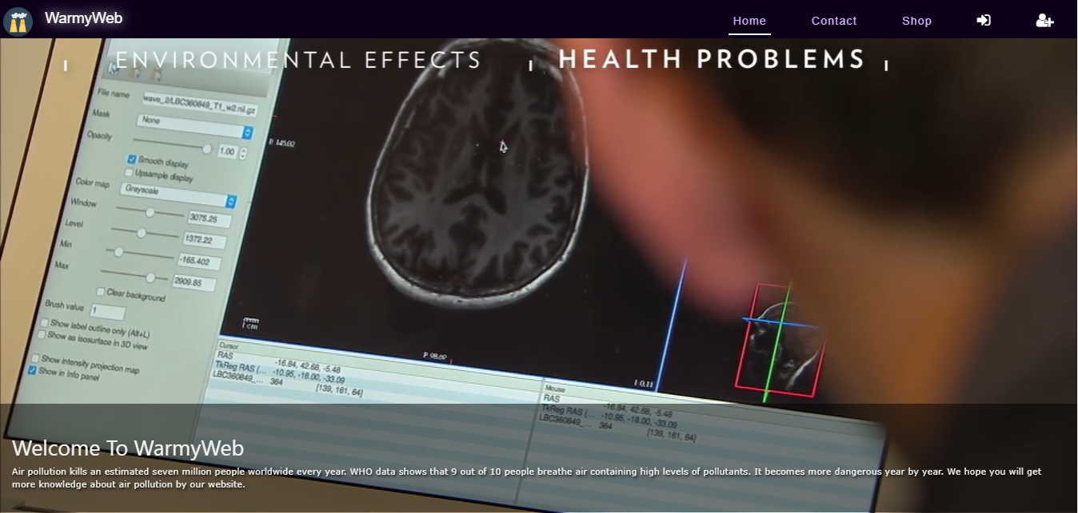

**Fig (6.1)**

A video is auto loading at the top of the webpage with a caption on it.

* **Fluid layout**

**Test case 7**

|  |  |
| --- | --- |
| Test objective | Testing if fluid layout is contained in main page. |
| Test Data |  |
| Test Procedure | Check the main page. |
| Expected Result | Fluid layout is contained. |
| Actual Result | See Fig (7.1) |

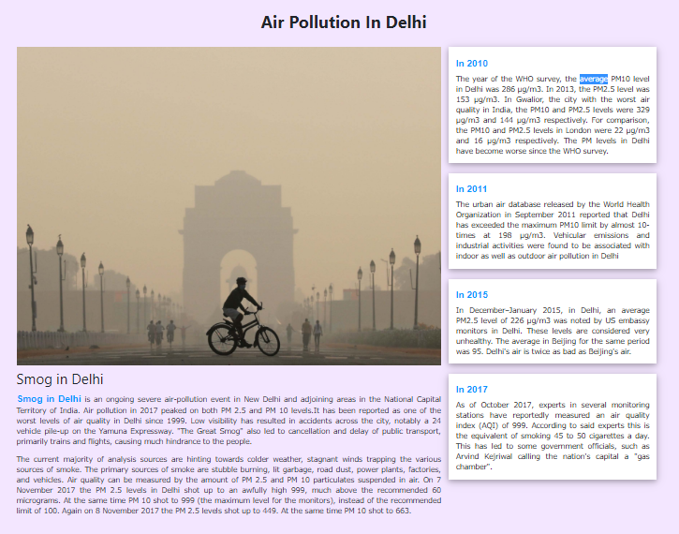

**Fig (7.1)**

Fluid layout is used to display the air pollution in Delhi year by year.

* **Animated/ interactive social media buttons or navigation buttons**

**Test case 8**

|  |  |
| --- | --- |
| Test objective | Testing if animated social media buttons are contained in main page. |
| Test Data |  |
| Test Procedure | Check the footer section of the main page. |
| Expected Result | Animated social media buttons are contained. |
| Actual Result | See Fig (8.1) |

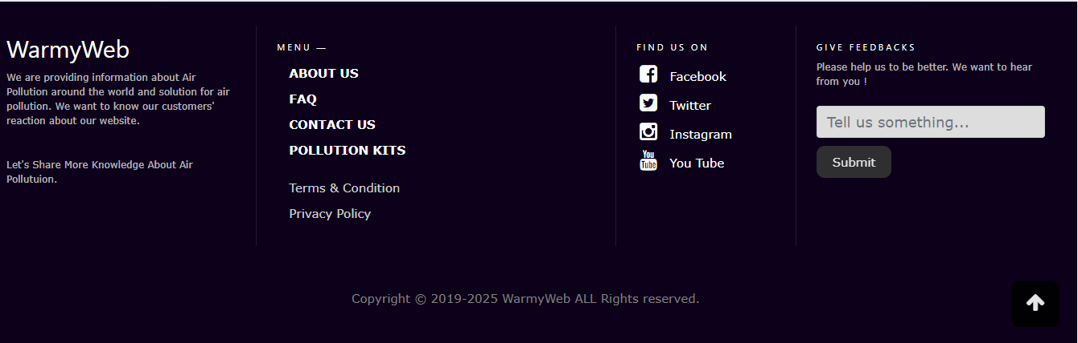

**Fig (8.1)**

There are animated social media buttons in the footer sections.

* **TWO media links to relevant pollution websites**

**Test case 9**

|  |  |
| --- | --- |
| Test objective | Testing if media links work or not. |
| Test Data |  |
| Test Procedure | Click on the media link. |
| Expected Result | The linked website is reached. |
| Actual Result | See Fig (9.1, 9.2) |

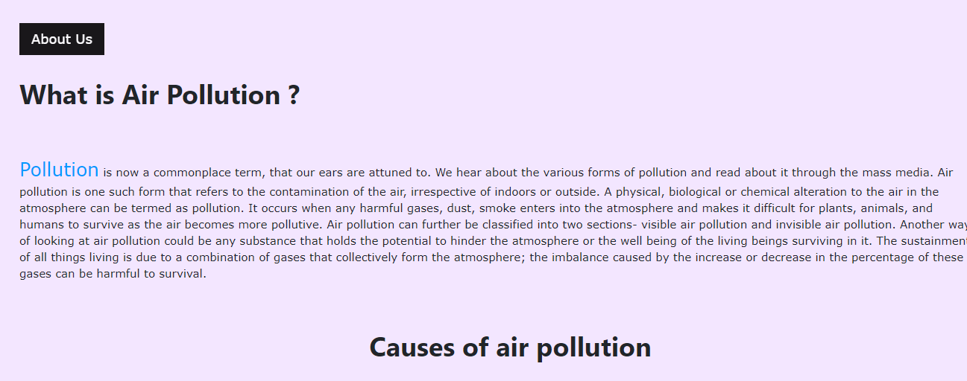

**Fig (9.1)**

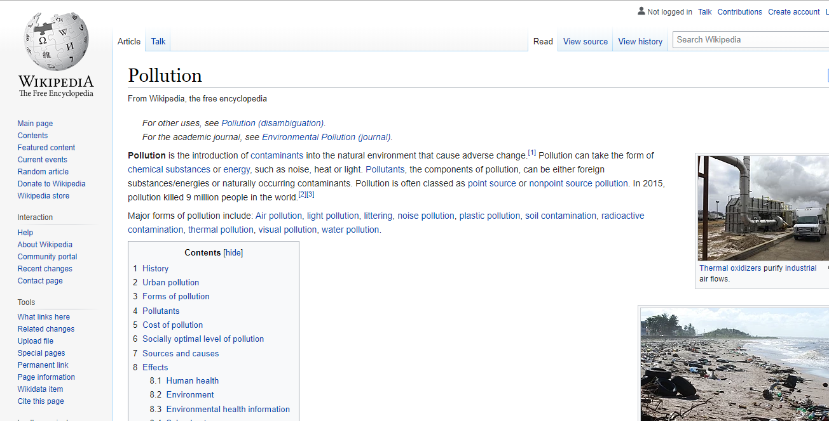

**Fig (9.2)**

When user click on the media link, the related website will be reach.

* **At least one call to action button**

**Test case 10**

|  |  |
| --- | --- |
| Test objective | Testing if main page includes at least one call to action button. |
| Test Data |  |
| Test Procedure | Check the about us button. |
| Expected Result | About Us modal box containing call to action button is shown. |
| Actual Result | See Fig (10.1, 10.2) |

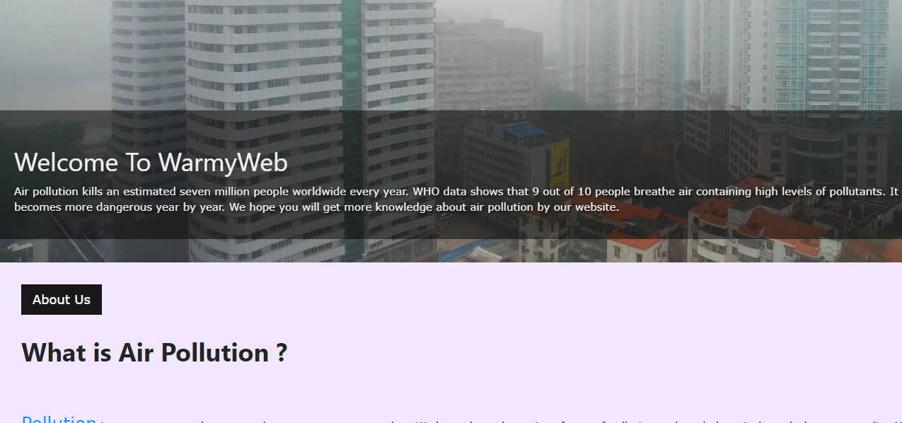

**Fig (10.1)**

When user click on the about us button, a modal box will appear.

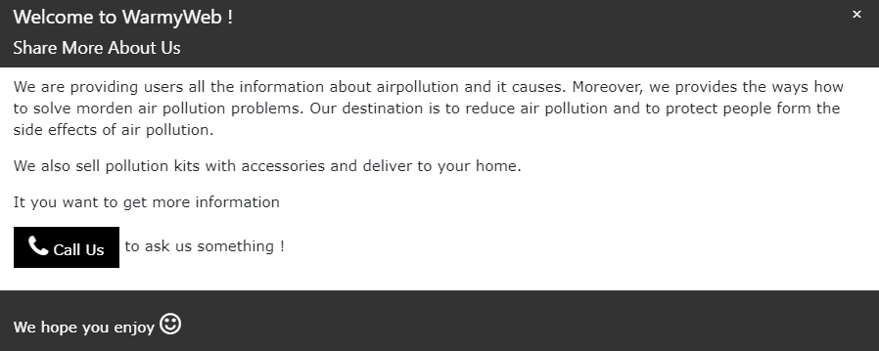

**Fig (10.2)**

**There is call to action button “Call Us”.**

* **An Offer for free home pollution kit**

**Test case 11**

|  |  |
| --- | --- |
| Test objective | Testing if free home pollution testing kit is pop up when user hover over sign up button. |
| Test Data |  |
| Test Procedure | Hover over the sign up button |
| Expected Result | An offer for free home pollution kit is pop up. |
| Actual Result | See Fig (11.1, 11. 2) |

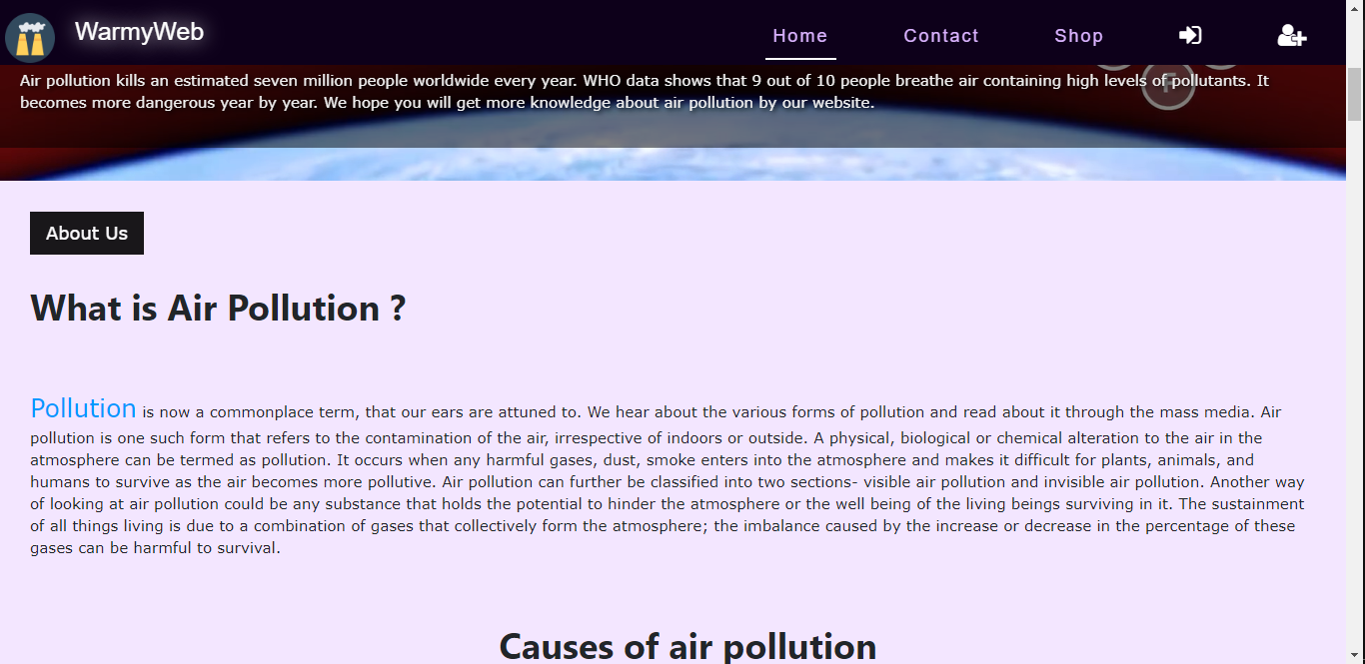

**Fig(11.1)**

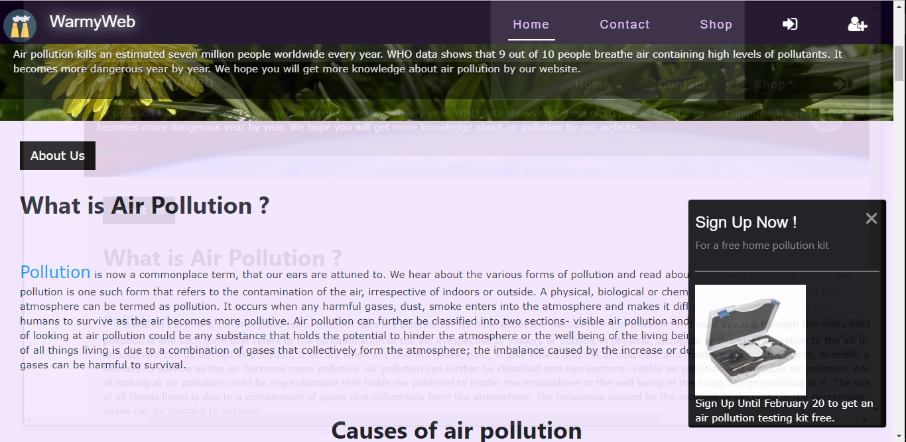

**Fig(11.2)**

Task 2

## **Analysis**

Task (2) is to create login and a registration system. Users must be able to register new accounts and log into their accounts with correct information. The database needs to save user’s full name, email address, date of birth, postal address and post code. Each users must have unique user name or email to register an account. For the higher security system, the passwords saved in the database must be used a hashing function before storing. When users log into their accounts, it is limited that user can only submit wrong data 3 times.

## **Assumption**

A new database has to be created for login and registration system. To register an account, users need to fill all the required information, their full name, unique email address, date of birth and postal address. A strong and secure password must be input to register an account. There is a script that check password strength ( password must contain at least 8 characters, a lowercase and uppercase letter and a number ). User will not be able to register an account if the input email already has an account. Before the password is stored in the database, it is protected by using a hash method called BCRYPT for the stronger security measure. Users are limited that they can only make wrong input 3 times. If a user input wrong data while logging in, the login form will disappear, a countdown time stamp will be displayed instead. That countdown stamp will last ten minutes. After waiting for ten minutes, the login form will be displayed again.

## **Screen Design**

UserLogin.php

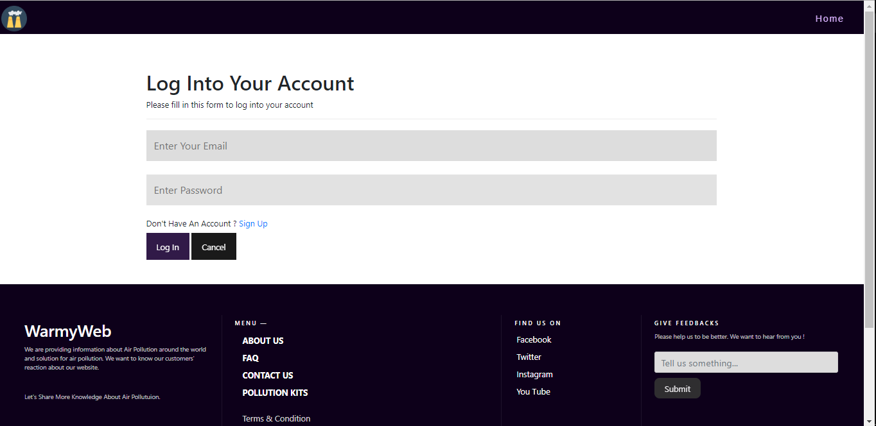

UserReg.php

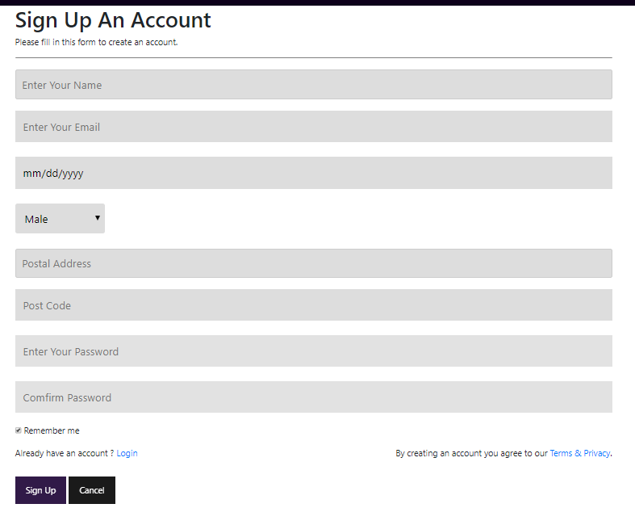

## 

## **Coding**

UserReg.php

<?php

$connect = mysqli_connect("localhost", "root","", "airpollutionDB");

if (isset($_POST ['btnSubmit']))

{

$name = ($_POST['txtname']);

$email = ($_POST['txtemail']);

$date = ($_POST['txtdob']);

$gender = ($_POST['cboGender']);

$postadd = ($_POST['txtpostadd']);

$postcode = ($_POST['txtpostcode']);

$password = ($_POST['psw']);

$password2 = ($_POST['psw-repeat']);

if ($password == $password2)

{

$emailcheck = "SELECT * FROM user WHERE 'email' = '$email'";

$run = mysqli_query($connect, $emailcheck);

$count = mysqli_num_rows($run);

if ($count == 0)

{

$hash = password_hash($password, PASSWORD_BCRYPT);

$Insert = "INSERT INTO `user`(`username`, `email`, `dob`, `gender`, `postaladdress`, `postcode`, `Password`) VALUES ('$name','$email','$date','$gender','$postadd','$postcode','$hash')";

$run = mysqli_query($connect, $Insert);

if ($run)

{

echo "

<script>

alert('Welcome $name. Your Account Is Created !');

window.location = 'UserLogin.php';

</script>

";

}

else

{

echo mysqli_error($connect);

}

}

else

{

echo "

<script>

alert('This Email Already Has An Account !');

window.location = 'UserReg.php';

</script>

";

}

}

else

{

echo "

<script>

alert('Password Are Not Match');

</script>

";

} } ?>

<!DOCTYPE html>

<html>

<head>

<title>Air | Sign Up</title>

<link rel="stylesheet" type="text/css" href="style.css">

<link rel="stylesheet" href="https://stackpath.bootstrapcdn.com/font-awesome/4.7.0/css/font-awesome.min.css ">

<link rel="stylesheet" href="https://stackpath.bootstrapcdn.com/bootstrap/4.3.1/css/bootstrap.min.css" >

<script src="https://code.jquery.com/jquery-3.3.1.slim.min.js"></script>

<script src="https://cdnjs.cloudflare.com/ajax/libs/popper.js/1.14.7/umd/popper.min.js"></script>

<script src="https://stackpath.bootstrapcdn.com/bootstrap/4.3.1/js/bootstrap.min.js"></script>

</head>

<body>

<!-- The Modal -->

<div id="myModal" class="modal">

<!-- Modal content -->

<div class="modal-content">

<header>

<span class="close">&times;</span>

<h3>Sign Up Now !</h3>

<h6>For a free home pollution kit</h6>

</header>

<hr>

<img src="media/freekit.jpg" class="freekit">

<p class="kitinfo">

Sign Up Until February 20 to get an air pollution testing kit free.

</p>

</div>

</div>

<section id="nav-bar">

<nav class="navbari navbar-expand-lg navbar-light">

<button class="navbar-toggler" type="button" data-toggle="collapse" data-target="#navbarNav" aria-controls="navbarNav" aria-expanded="false" aria-label="Toggle navigation">

<i class="fa fa-bars"></i>

</button>

<div class="collapse navbar-collapse" id="navbarNav">

<img src="media/weblogo.png" width="50px">

<ul class='navbar-nav ml-auto' >

<li class='nav-item'>

<a class='nav-link' href='Main.php'>Home<span class='sr-only'>(current)</span></a>

</li>

</ul>

</div>

</nav>

</section>

<!------------Form---------------->

<form action="#" method="POST" enctype="multipart/form-data" >

<div class="container">

<h1>Sign Up An Account </h1>

<p>Please fill in this form to create an account.</p>

<hr>

<input type="text" placeholder="Enter Your Name" name="txtname" required>

<input type="email" placeholder="Enter Your Email" name="txtemail" required>

<input type="Date" placeholder="Enter Date Of Birth (YY-MM-DD)" name="txtdob" required>

<select name="cboGender" class="selc" placeholder="Choose Gender" required>

<option> Male</option>

<option> Female</option>

<option> Unspecified</option>

</select>

<input type="text" placeholder="Postal Address" class="selc" name="txtpostadd" required>

<input type="number" placeholder="Post Code" class="selc" name="txtpostcode" required>

<input type="password" id="psw" name="psw" placeholder="Enter Your Password" required>

<input type="password" placeholder="Comfirm Password" name="psw-repeat" required>

<label>

<input type="checkbox" checked="checked" name="remember" style="margin-bottom:15px"> Remember me

</label><br>

<label>Already have an account ? <a href="UserLogin.php"> Login</a></label>

<p class="terms">By creating an account you agree to our <a href="#">Terms & Privacy</a>.</p> <br><br>

<div class="clearfix">

<button type="submit" name="btnSubmit" class="signupbtn" id="mybtn">Sign Up</button>

<button type="reset" class="cancelbtn"><a href="Main.php"></a>Cancel</button>

</div>

</div>

</form><br><br>

</html>

UserLogin.php

<?php

session_start();

$connect = mysqli_connect("localhost", "root","", "airpollutionDB");

if (isset ($_POST ['btnlogin']))

{

$mail = $_POST['txtemail'];

$pass = $_POST['txtpsw'];

$select = "SELECT * FROM user WHERE email ='$mail'";

$run = mysqli_query($connect, $select);

$count = mysqli_num_rows($run);

if ($count >= 0){

$data = mysqli_fetch_array($run);

$uid = $data[0];

$_SESSION['name'] = $mail;

$_SESSION['id'] = $uid;

if (password_verify($pass, $data['password'])) {

$date = date('Y-m-d');

$userid = $_SESSION['id'];

$insert = "INSERT INTO `history` (`historydate`, `userid`, `PageName`) VALUES ('$date', '$userid', 'UserLogin.php')";

$run = mysqli_query($connect, $insert);

echo "

<script>

alert('Logged In Successfully !');

window.location = 'Main.php';

</script>

"; }

else{

if (!isset($_SESSION['count']))

{

$_SESSION['count'] = 1;

}

else

{

$_SESSION['count'] += 1;

}

if ($_SESSION['count']>=3)

{

$_SESSION['check'] = 1;

echo "

<script>

alert('Log in fail for 3 times. Please wait 10 minutes.');

</script>

";}

else

{

echo "

<script>

alert('Try Again');

</script>"; }} }

else {

echo "

<script>

alert('The Email You Input Doesn't Match Any Account !');

</script>

";} }

?>

<!DOCTYPE html>

<html>

<head>

<title>Air | Log In</title>

<link rel="stylesheet" type="text/css" href="style.css">

<link rel="stylesheet" href="https://stackpath.bootstrapcdn.com/font-awesome/4.7.0/css/font-awesome.min.css ">

<link rel="stylesheet" href="https://stackpath.bootstrapcdn.com/bootstrap/4.3.1/css/bootstrap.min.css" >

<script src="https://code.jquery.com/jquery-3.3.1.slim.min.js"></script>

<script src="https://cdnjs.cloudflare.com/ajax/libs/popper.js/1.14.7/umd/popper.min.js"></script>

<script src="https://stackpath.bootstrapcdn.com/bootstrap/4.3.1/js/bootstrap.min.js"></script>

<!-- Timer Code -->

<style type="text/css">

.timer

{

width: 100px;

font-size: 2.5em;

text-align: center;

}

</style>

<script type="text/javascript">

var seconds = 600;

function secondPassed()

{

var minutes = Math.round((seconds - 30)/60),

remainingSeconds = seconds % 60;

if (remainingSeconds < 10)

{

remainingSeconds = "0" + remainingSeconds;

}

document.getElementById('countdown').innerHTML = minutes + ":" + remainingSeconds;

if (seconds == 0)

{

clearInterval(countdownTimer);

//form1 is your form name

window.location.href = "userlogin.php";

}

else

{

seconds--;

}

}

var countdownTimer = setInterval('secondPassed()', 1000);</script>

<!-- Timer Code -->

</head>

<section id="nav-bar">

<nav class="navbari navbar-expand-lg navbar-light">

<button class="navbar-toggler" type="button" data-toggle="collapse" data-target="#navbarNav" aria-controls="navbarNav" aria-expanded="false" aria-label="Toggle navigation">

<i class="fa fa-bars"></i>

</button>

<div class="collapse navbar-collapse" id="navbarNav">

<img src="media/weblogo.png" width="50px">

<ul class='navbar-nav ml-auto' >

<li class='nav-item'>

<a class='nav-link' href='Main.php'>Home<span class='sr-only'>(current)</span></a>

</li>

</ul>

</div>

</nav>

</section>

<?php

if (isset($_SESSION['check']))

{

echo

"

<div class='timer'> <time id='countdown'>10:00</time></div>

";

unset($_SESSION['check']);

unset($_SESSION['count']);

}

else

{

?>

<!------------From--------------->

<form action="UserLogin.php" method="POST" enctype="multipart/form-data">

<div class="container">

<h1>Log Into Your Account</h1>

<p>Please fill in this form to log into your account</p>

<hr>

<input type="email" placeholder="Enter Your Email" name="txtemail" required>

<input type="password" placeholder="Enter Password" name="txtpsw" required>

<label>Don't Have An Account ? <a href="UserReg.php"> Sign Up</a></label>

<div class="clearfix">

<button type="submit" name="btnlogin" class="signupbtn">Log In</button>

<button type="reset" class="cancelbtn">Cancel</button>

</div>

</div>

</form> <br><br>

</body>

</html>

## **Testing**

* Login and registration system.

**Test Case 1**

|  |  |
| --- | --- |
| Test objective | The warning alert is shown or not if a text box is left null. |
| Test Data | Postal Address = “ ” |
| Test Procedure | Leave a text box null and click Sign Up. |
| Expected Result | The warning alert is shown. |
| Actual Result | See Fig (1.1) |

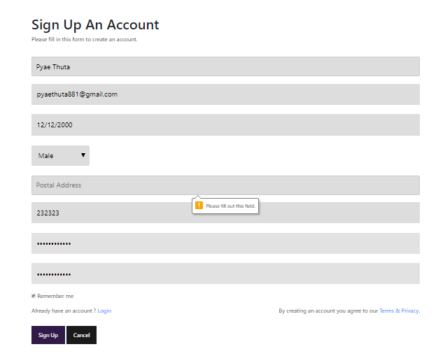

**Fig (1.1)**

The registration will not be done if user doesn’t fill all the required information.

**Test Case 2**

|  |  |
| --- | --- |
| Test objective | Unsuccessful message box is shown or not when user input the password boxes with unmatched data. |
| Test Data | Password=” Pyaethuta881”  Confirm Password = “Pyaethuta118” |
| Test Procedure | Fill the password boxes with unmatched data |
| Expected Result | Show unsuccessful message to user. |
| Actual Result | See Fig (2.1) |

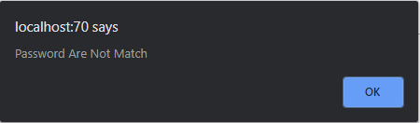

**Fig (2.1)**

There are two text boxes “Password” and “Confirm Password” to ensure that users input their desire password correctly. If users don’t input same password, the above message box will be shown.

**Test Case 3**

|  |  |
| --- | --- |
| Test objective | A java script form for restriction is shown or not when user focus on the password box. |
| Test Data |  |
| Test Procedure | Focus in the password box. |
| Expected Result | Show a java form for restriction. |
| Actual Result | See Fig (3.1, 3.2) |

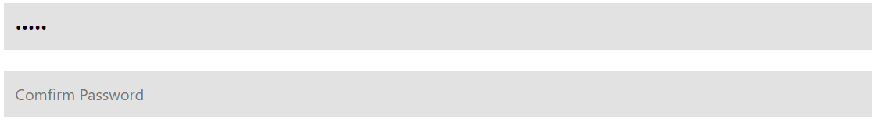

**Fig (3.1)**

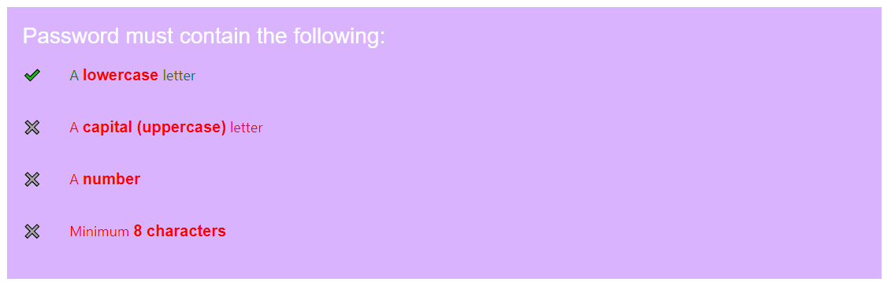

**Fig (3.2)**

**Test Case 4**

|  |  |
| --- | --- |
| Test objective | Unsuccessful message is shown or not when user input the email address that already has an account. |
| Test Data | Email = “pyaethuta881@gmail.com” |
| Test Procedure | Input the email address that already has an account. |
| Expected Result | Unsuccessful message is shown. |
| Actual Result | See Fig (4.1, 4.2) |

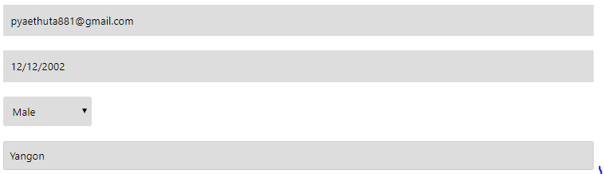

**Fig (4.1)**

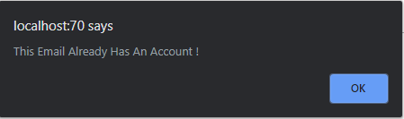

**Fig (4.2)**

**Test Case 5**

|  |  |
| --- | --- |
| Test objective | Successful message is shown or not when all the data correctly. |
| Test Data | Email = “ivan@gmail.com” |
| Test Procedure | Input all fields with correct data and check the data in the database. |
| Expected Result | Successful message is shown, and the data is stored in the database correctly. |
| Actual Result | See Fig (5.1, 5.2, 5.3) |

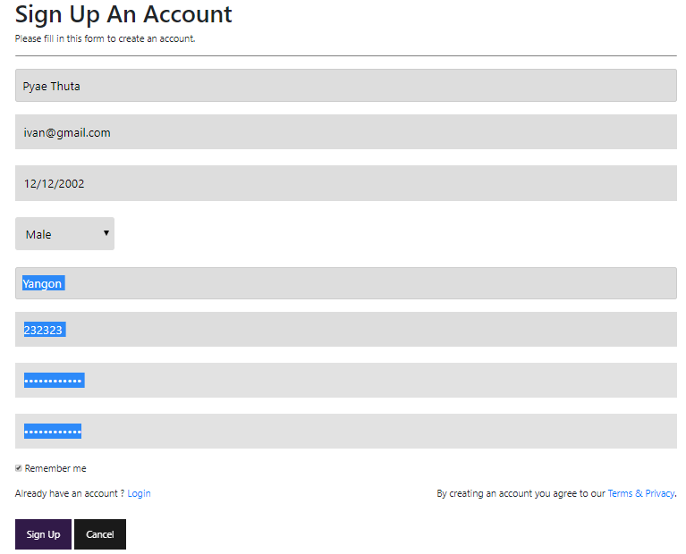

**Fig (5.1)**

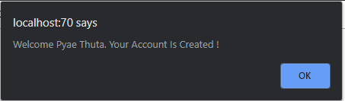

**Fig (5.2)**  If user input all field with correct data, the above message box will be shown, and the user account is created. The input data will be stored in the database.



**Fig (5.3)**

**UserLogin.php**

**Test Case 1**

|  |  |
| --- | --- |
| Test objective | The error message box is shown or not when user input wrong data. |
| Test Data | Email.com = “Pyaethuta8821@gmail.com” |
| Test Procedure | Input wrong email and password in the text boxes and click Log In button. |
| Expected Result | Show unsuccessful message to user. |
| Actual Result | See Fig (1.1, 1.2) |

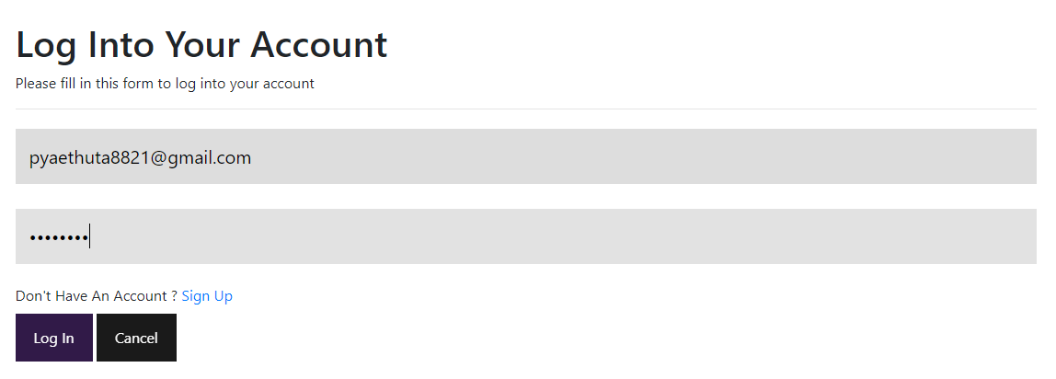

**Fig (1.1)**  Input wrong email or password and click “Log In” action button.

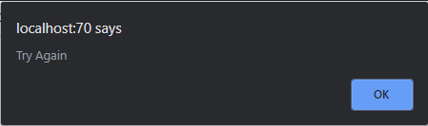

**Fig (1.2)**  Unsuccessful message is shown.

**Test Case 2**

|  |  |
| --- | --- |
| Test objective | The successful message is shown, and main page is reached or not if user tests with correct data. |
| Test Data | Email = “[ivan@gmail.com](mailto:ivan@gmail.com)”  Password = “Pyaethuta881” |
| Test Procedure | Input correct email and password in the text boxes and click Log In button. |
| Expected Result | Show successful message and main page is reached. |
| Actual Result | See Fig (2.1, 2.2, 2.3) |

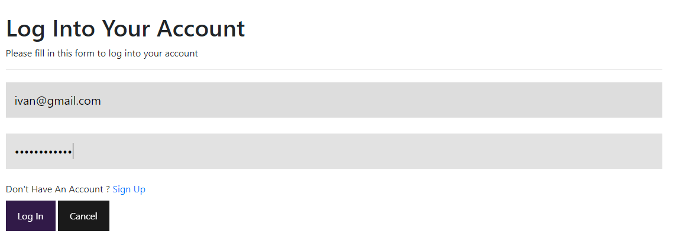

**Fig (2.1)**

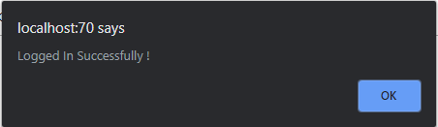

**Fig (2.2)**

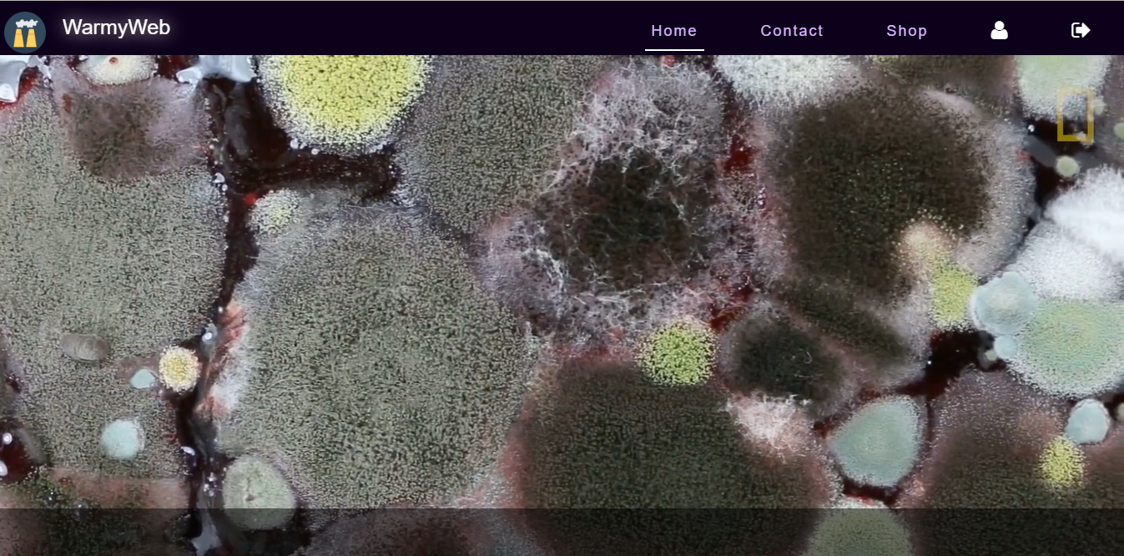

**Fig (2.3)**

* Use Password hashing as a security measure

**Test Case 1**

|  |  |
| --- | --- |
| Test objective | The input password is stored in the database with hash method or not after successful message is shown. |
| Test Data |  |
| Test Procedure | View the input data in database after success message is shown. |
| Expected Result | The password is stored in the database with hash method. |
| Actual Result | See Fig (1.1, 1.2) |



**Fig (1.1)**



**Fig (1.2)**  The password input is hash with BCRYPT method before storing in the database.

* Three attempts at a login to lock the account for TEN minutes if fails

**Test Case 1**

|  |  |
| --- | --- |
| Test objective | The account is lock ten minutes or not if logging is failed three times. |
| Test Data | Email = [Tuit@gmail.com](mailto:Tuit@gmail.com)  Password = “tuit1” |
| Test Procedure | Input incorrect data in the login form three times. |
| Expected Result | The form will disappear, and the account is lock for 10 minutes. |
| Actual Result | See Fig (1.1, 1.2, 1.3, 1,4) |

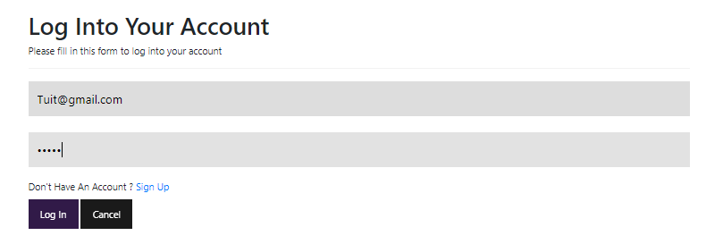

**Fig (1.1)**

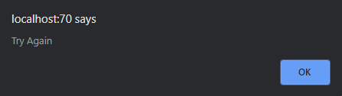

**Fig (1.2)**

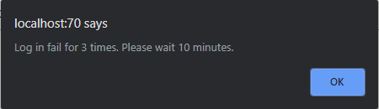

**Fig (1.3)**

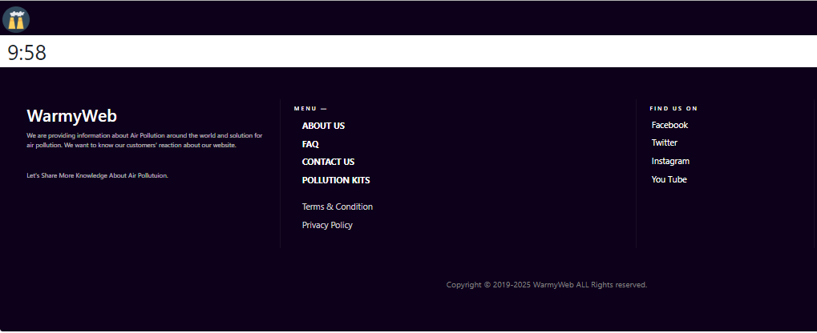

**Fig (1.4)**

**Test Case 2**

|  |  |
| --- | --- |
| Test objective | The account is unlocked or not if after ten minutes. |
| Test Data |  |
| Test Procedure | Wait ten minutes of locking after failing login three times. |
| Expected Result | The form will appear, and the account is unlocked after 10 minutes locking. |
| Actual Result | See Fig (2.1, 2.2) |

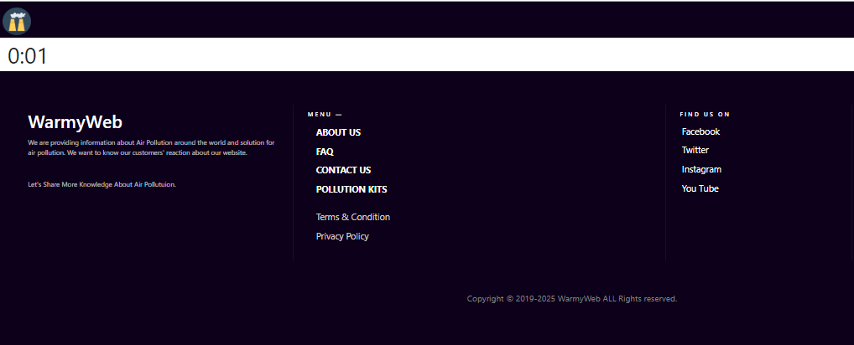

**Fig (2.1)**

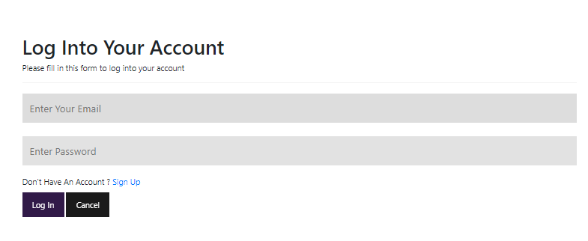

**Fig (2.2)**

* Updating User Information

**Test Case 1**

|  |  |
| --- | --- |
| Test objective | Testing if the user information is updated when users change their information and click “Update” action button. |
| Test Data | Postal Address = “Thingangyun” |
| Test Procedure | Change postal address and click “Update” button. |
| Expected Result | The postal address is updated. |
| Actual Result | Fig (1.1, 1.2, 1.3, 1.4) |

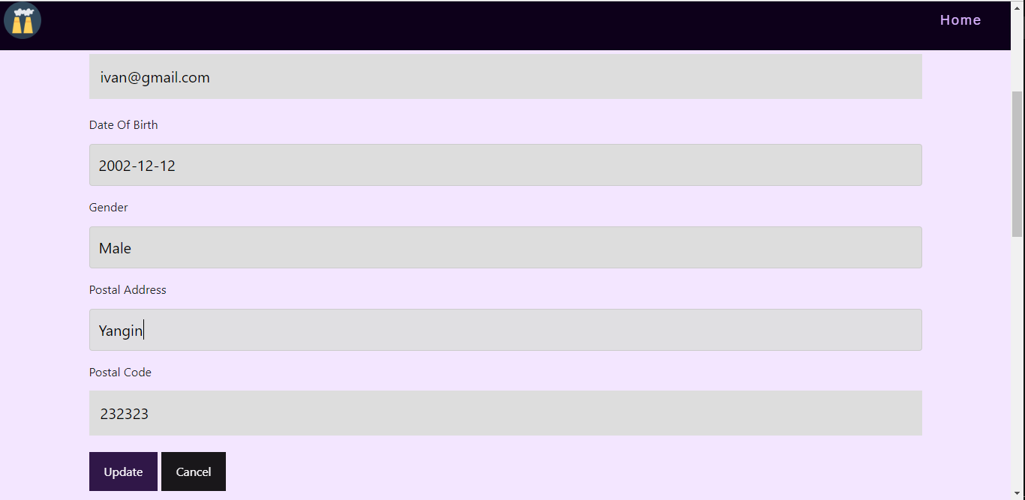

**Fig (1.1)** Postal Address before updating.

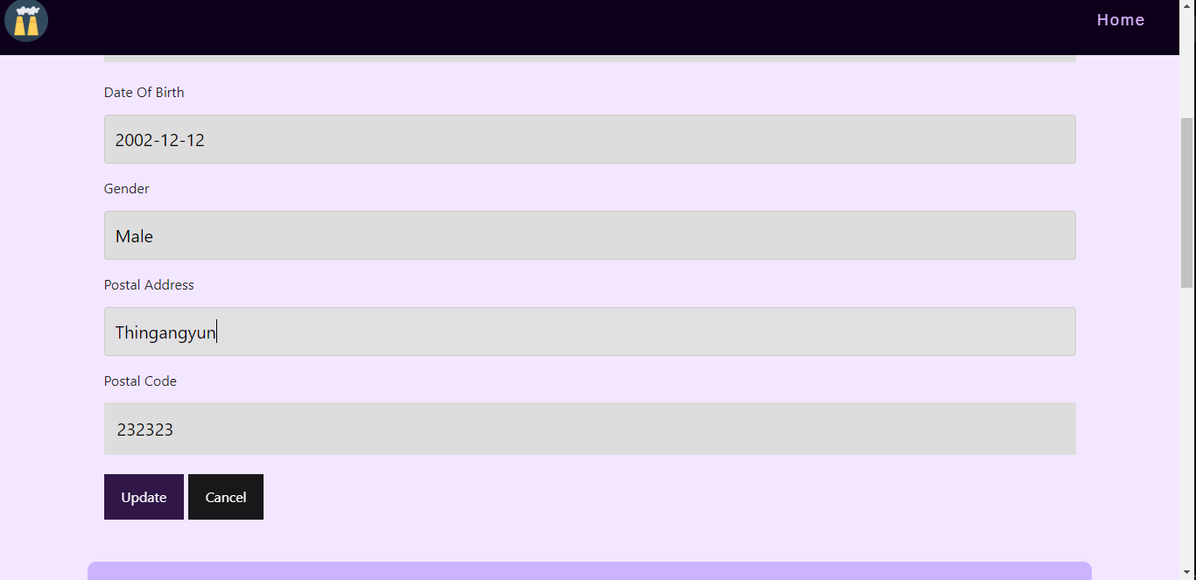

**Fig (1.2)** Change Postal Address and click “Update”.

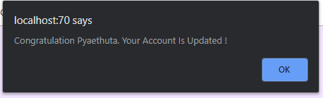

**Fig (1.3)**  The message box is shown

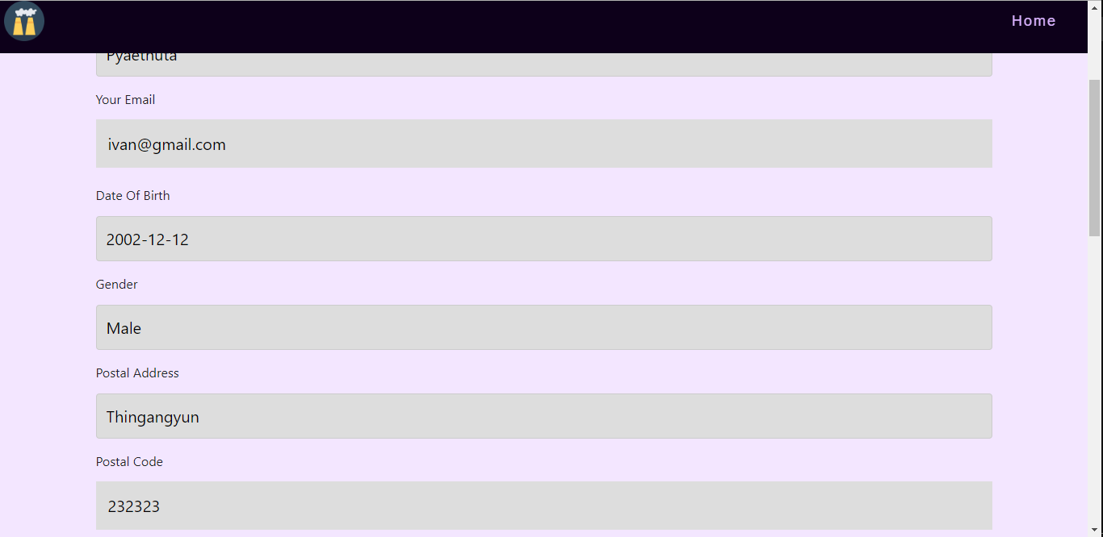

**Fig (1.4)**  Postal Address after updating.

**Test Case 2**

|  |  |
| --- | --- |
| Test objective | Testing if the update password page is not reached when user input incorrect password. |
| Test Data | Password = “pyaepyae11” |
| Test Procedure | Input Wrong password. |
| Expected Result | The unsuccessful message box is shown. |
| Actual Result | Fig (2.1, 2.2) |

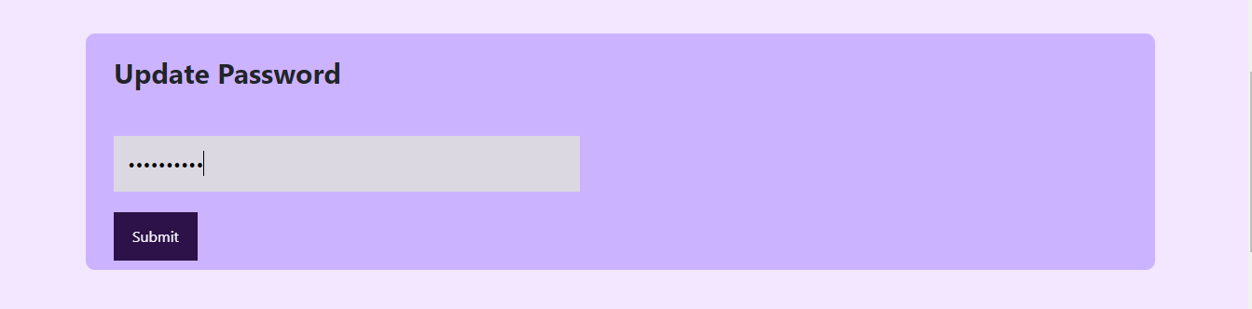

**Fig (2.1)**  Input wrong password.

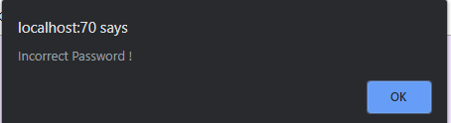

**Fig (2.2)**  The unsuccessful message box is shown.

**Test Case 3**

|  |  |
| --- | --- |
| Test objective | Testing if the update password page is reached when user input correct password. |
| Test Data | Password = “Pyaethuta881” |
| Test Procedure | Input correct password. |
| Expected Result | The successful message box is shown, and update password page is reached. |
| Actual Result | Fig (3.1, 3.2, 3.3) |

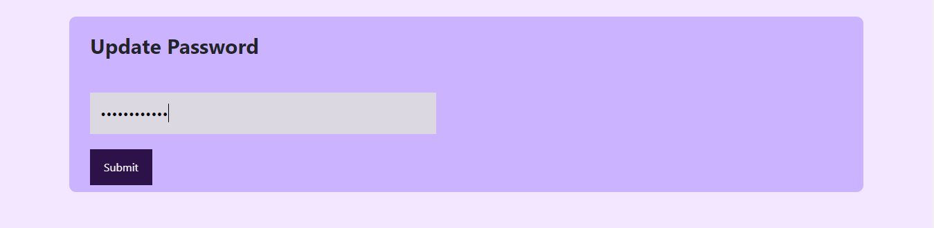

**Fig (3.1)** Input correct password

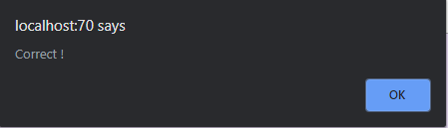

**Fig (3.2)** Successful message box is shown.

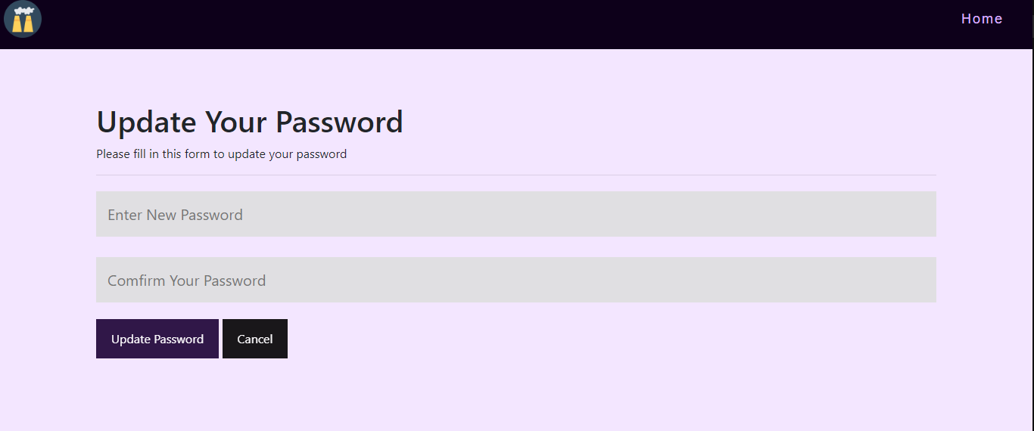

**Fig (3.3)** Update password page is reached.

**Test Case 4**

|  |  |
| --- | --- |
| Test objective | Testing if successful message box is shown and password is updated when user input password and click “Update Password”. |
| Test Data | Password = “Pyaethuta882” |
| Test Procedure | Input same password in the two password box. |
| Expected Result | The successful message box is shown. |
| Actual Result | Fig (4.1, 4.2) |

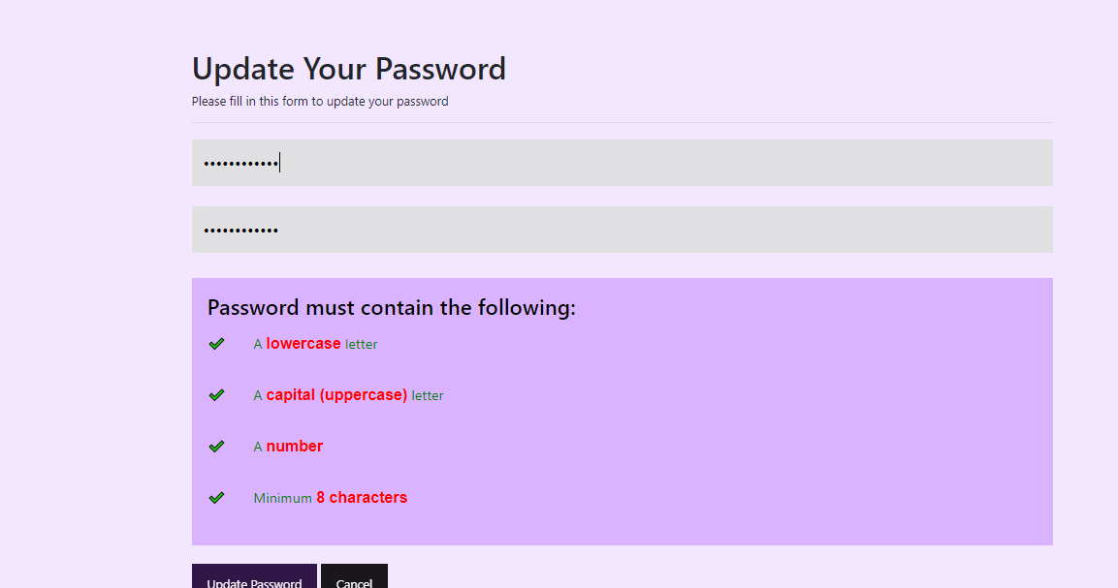

**Fig (4.1)** Input two password boxes with same password and click button.

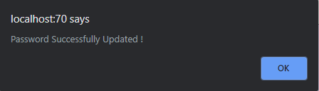

**Fig (4.2)** Successful message box is shown.

Task 3

## **Analysis**

Users must be able to access their accounts after logging in successfully. There must be an online contact us form which contain FAQ section where users can ask questions. Users should see a set of FAQ answer before submitting the question.

## **Assumption**

Users can navigate to the “Contact Us” page form Main Page by the button on the top navigation bar. In the contact us page, there is a text box where users can submit their questions. Whenever a user submits a question, the question ID, the question, user ID and the date that the question is asked are stored in the database. These questions will be displayed in the staff main form where staffs can reply these questions. The replied answers are displayed in the FAQ section of contact us page. In that section, users can see not only questions and answers but also the user name and respective date. Questions without answers will not be displayed in the FAQ section.

## **Screen Design**

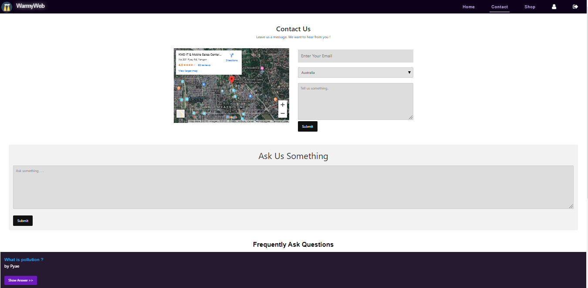

## **Coding**

contact.php

<?php

session_start();

$connect = mysqli_connect("localhost", "root","", "airpollutionDB");

if (isset($_POST ['btnSubmit']))

{

if (!isset($_SESSION['name']))

{

echo "

<script>

alert('You Need To Logged In First !');

window.location = 'UserLogin.php';

</script>

";

}

else

{

$mail = $_SESSION['name'];

$qdate = $_POST ['txtqdate'];

$question = $_POST ['txtquestion'];

$select1 = "SELECT * FROM user WHERE email = '$mail' ";

$run1 = mysqli_query($connect, $select1);

$row1 = mysqli_fetch_array($run1);

$uid = $row1[0];

$Insert = "INSERT INTO `question`(`qdate`,`question`, `userid`) VALUES ('$qdate','$question','$uid')";

$run = mysqli_query($connect, $Insert);

if ($run)

{

echo "

<script>

alert('Your Question Is Submitted !');

</script>

"; }

else

{

echo mysqli_error($connect);

} }} ?>

<!---------------ASK SECTION ----------->

<div class="container2">

<p class="ask-head">Ask Us Something</p>

<form action="contact.php" method="post">

<input type="hidden" id="fname" class="qdate" name="txtqdate" value="<?php echo date('Y-M-D');?>">

<textarea id="subject" name="txtquestion" placeholder="Ask something . . ." style="height:200px" required></textarea><br><br>

<input type="submit" value="Submit" name="btnSubmit">

</form> </div>

<!---------- FAQ Section -------->

<section class="faq-sec">

<h2>Frequently Ask Questions</h2>

<?php

$select = "SELECT * FROM question WHERE answer != '' ";

$run = mysqli_query($connect, $select);

$count = mysqli_num_rows($run);

for ($i=0; $i < $count; $i++)

{

$row = mysqli_fetch_array($run);

$question = $row[2];

$cid = $row[3];

$sid = $row[4];

$date = $row[5];

$ans = $row[6];

$select1 = "SELECT * FROM staff WHERE staffid = '$sid' ";

$run1 = mysqli_query($connect, $select1);

$row1 = mysqli_fetch_array($run1);

$sname = $row1[1];

$select2 = "SELECT * FROM user WHERE userid = '$cid' ";

$run2 = mysqli_query($connect, $select2);

$row2 = mysqli_fetch_array($run2);

$uname = $row2[1];

echo "

<button class='accordion' style='background-color:#0d001a;'><b>$question</b><br>by $uname <br><br>

<input type='submit' value='Show Answer >>' id='accordion'

style='background-color:#5c00b3; width:150px; padding:10px; font-size:15px;'

> </button>

<div class='panel'>

<p style='font-size: 20px;'><h3>$ans</h3><br>by $sname<br>$date</p>

</div>

"; }

?>

**Testing**

**Test Case 1**

|  |  |
| --- | --- |
| Test objective | To test if the message is shown and login page is reached when user asked question without logging in. |
| Test Data | Ask = “In which country, air is the most polluted ?” |
| Test Procedure | Ask question without logging in. |
| Expected Result | Unsuccessful message is shown and login page is reached |
| Actual Result | See Fig (1.1, 1.2, 1.3) |

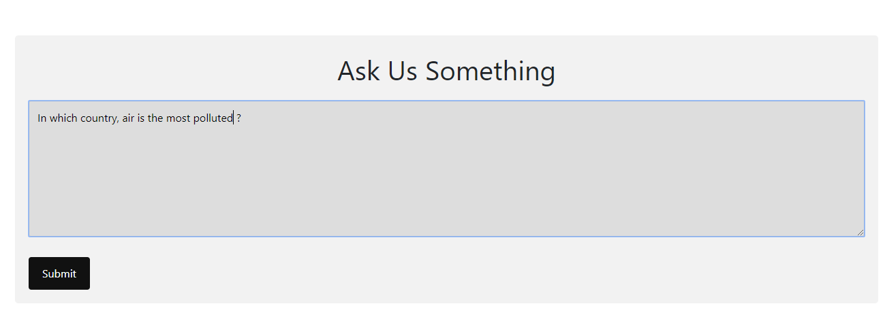

**Fig (1.1)**

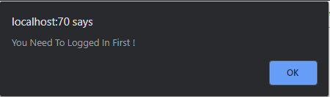

**Fig (1.2)**

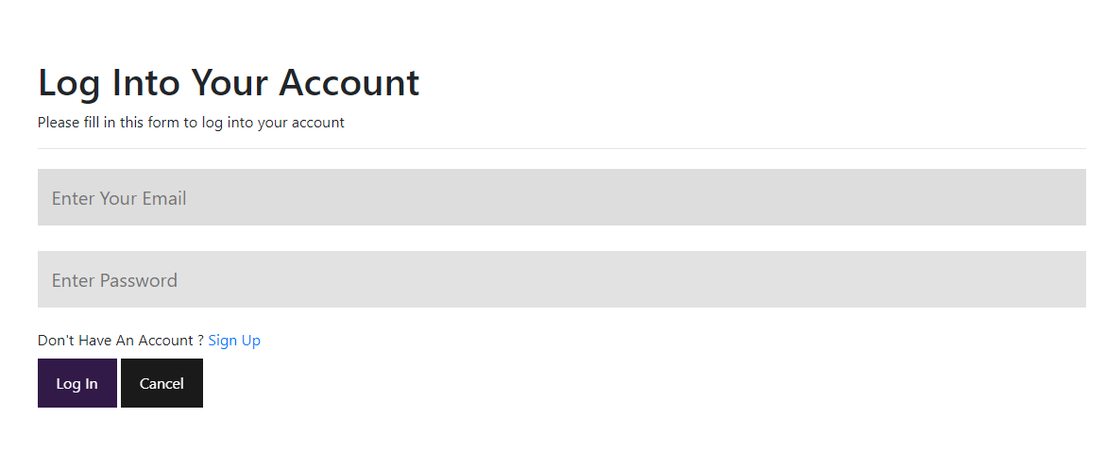

**Fig (1.3)**

**Test Case 2**

|  |  |
| --- | --- |
| Test objective | To test if the message is shown and question is stored in the database when user asked question after logging in. |
| Test Data | Ask = “In which country, air is the most polluted ?” |
| Test Procedure | Ask question after logging in. |
| Expected Result | Successful message is shown, and question is stored in the database. |
| Actual Result | See Fig (2.1, 2.2, 2.3) |

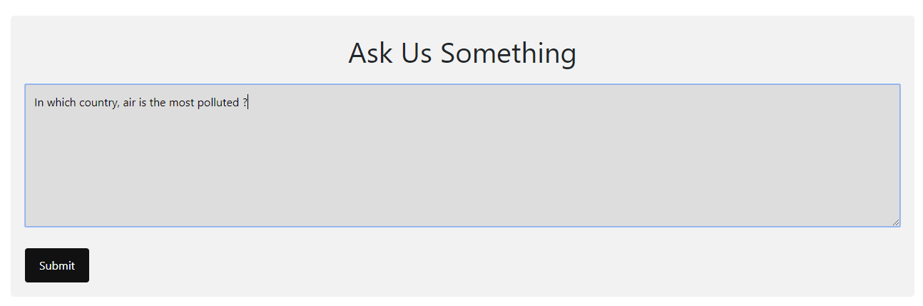

**Fig (2.1)**

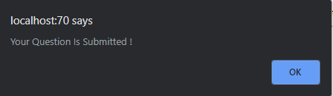

**Fig (2.2)**



**Fig (2.3)**

**Test Case 3**

|  |  |
| --- | --- |
| Test objective | To test if the question and answer is shown in the FAQ section after a staff replied the answer. |
| Test Data | Answer = “Delhi, Hong Kong and Yangon” |
| Test Procedure | Reply the question form the staff form and check FAQ section. |
| Expected Result | Successful message is shown, and the question and answer are shown in the FAQ section of contact us page. |
| Actual Result | See Fig (3.1, 3.2, 3.3) |

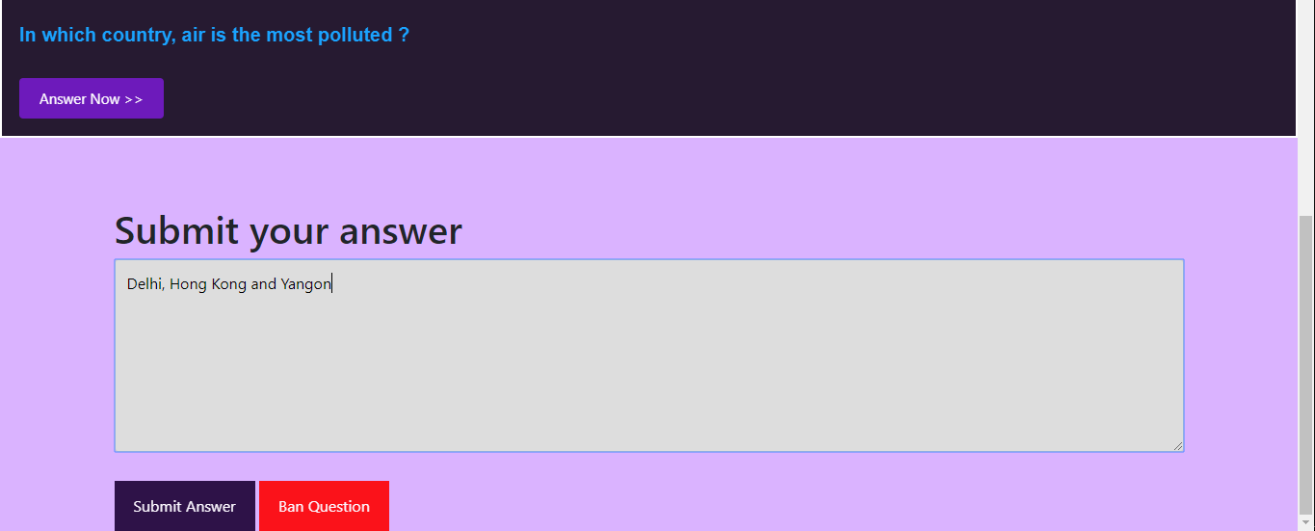

**Fig (3.1) Replying the question from staff form.**

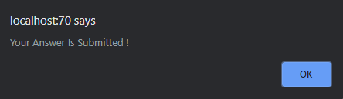

**Fig (3.2) Answer submitted.**



**Fig (3.3) Go to contact us page and check question.**

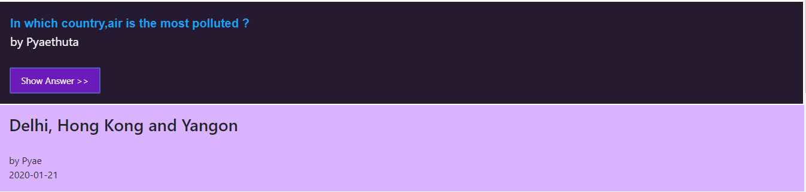

**Fig (3.4) The answer is shown.**

# 

# Task 4

**Analysis**

Task (4) is to make additional features that should be included in the website. The website must be accessible on mobile phone and tablet. It should be responsive and adaptive based on user needs. There should be a web service in website. The website must personalize the content with the adding the city name to the landing page as a personal touch.

## **Assumption**

The website is adaptive to all devices with the use of media query. It is responsive to all phones and tablet. There is a service in main page and user register form that the registered users can get free home pollution kit. The city name of the website is added in the landing page footer and contact us page.

**Coding**

style.css

@media (min-width: 768px) {

.footer-bs .footer-nav, .footer-bs .footer-social, .footer-bs .footer-ns { border-left:solid 1px rgba(255,255,255,0.10); }

}

@media screen and (max-width: 600px)

{

.column, input[type=submit]

{

width: 100%;

margin-top: 0;

}}

@media screen and (max-width: 600px)

{

.service

{ width: 100%; }}

@media screen and (max-width: 600px)

{ .cancelbtn, .signupbtn

{width: 100%; }

.nav-bar

{ width: 100%;

background-color: red; }}

UserReg.php

<!-- The Modal -->

<div id="myModal" class="modal">

<!-- Modal content -->

<div class="modal-content">

<header>

<span class="close">&times;</span>

<h3>Sign Up Now !</h3>

<h6>For a free home pollution kit</h6>

</header>

<hr>

<img src="media/freekit.jpg" class="freekit">

<p class="kitinfo">

Sign Up Until February 20 to get an air pollution testing kit free.

</p>

</div>

</div>

<script>

// Get the modal

var modal = document.getElementById("myModal");

// Get the button that opens the modal

var btn = document.getElementById("mybtn");

// Get the <span> element that closes the modal

var span = document.getElementsByClassName("close")[0];

// When the user clicks the button, open the modal

btn.onmouseover = function()

{ modal.style.display = "block";

modal.style.transition = "5s";}

// When the user clicks on <span> (x), close the modal

span.onclick = function()

{modal.style.display = "none"; }

// When the user clicks anywhere outside of the modal, close it

window.onclick = function(event) {

if (event.target == modal) {

modal.style.display = "none";}}

</script>

**Profile.php**

<table width="100%" class="tbl" >

<tr>

<td><b>Date</b></td>

<td><b>Product Name</b></td>

</tr>

<?php

$userid = $_SESSION['id'];

$select = "SELECT * FROM `purchase` WHERE userid = '$userid' ";

$run = mysqli_query($connect, $select);

$count = mysqli_num_rows($run);

if ( $count == 0 )

{

echo

"

<p style='padding-left:30px; margin-top:-70px; color:red;'>

<i class='fa fa-times' style='color:red;'> </i> No purchase was made !

</p>";}

else

{

for ($i=0; $i < $count; $i++)

{

$row = mysqli_fetch_array($run);

$pid = $row['productid'];

$date = $row['purchasedate'];

$select1 = "SELECT * FROM `product` WHERE productid = '$pid' ";

$run1 = mysqli_query($connect, $select1);

$row1 = mysqli_fetch_array($run1);

$pname = $row1['productname'];

echo "

<tr>

<td>$date</td>

<td>$pname</td>

</tr>";} }?></table><br><br>

## **Testing**

**Test Case 1**

|  |  |
| --- | --- |
| Test objective | To test if the website is responsive or not based on the user needs. |
| Test Data |  |
| Test Procedure | Run the webpage on a browser and minimize to minimal width. |
| Expected Result | The contents in the webpage will be responsive to be able to read and navigate. |
| Actual Result | See Fig (1.1, 1.2, 1.3) |

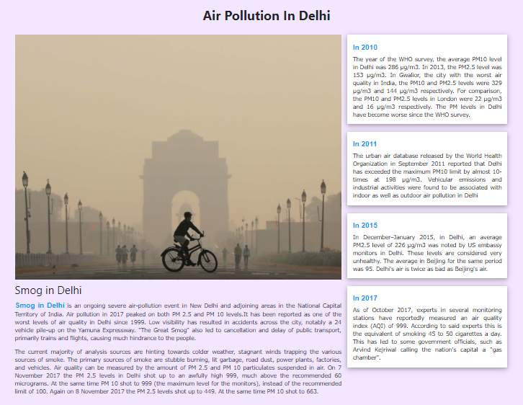

**Fig (1.1)** The fluid layoutinformation section in normal width.

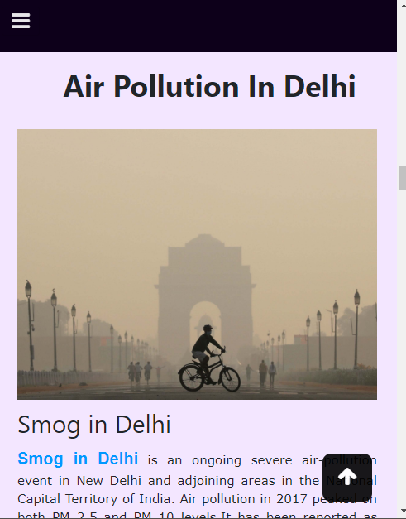

**Fig (1.2)** The image and main caption after minimizing to minimal width.

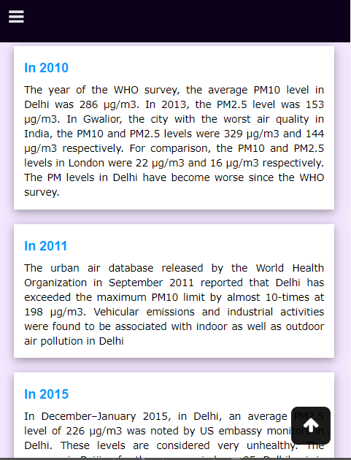

**Fig (1.3)** The fluid layout after minimizing to minimal width.

**Test Case 2**

|  |  |
| --- | --- |
| Test objective | To test if the website is accessible with phone or tablet. |
| Test Data |  |
| Test Procedure | Run the webpage on a browser and go to inspect. Then , choose phone or tablet. |
| Expected Result | The contents in the webpage will be responsive to the width of phone or tablet. |
| Actual Result | See Fig (2.1, 2.2, 2.3) |

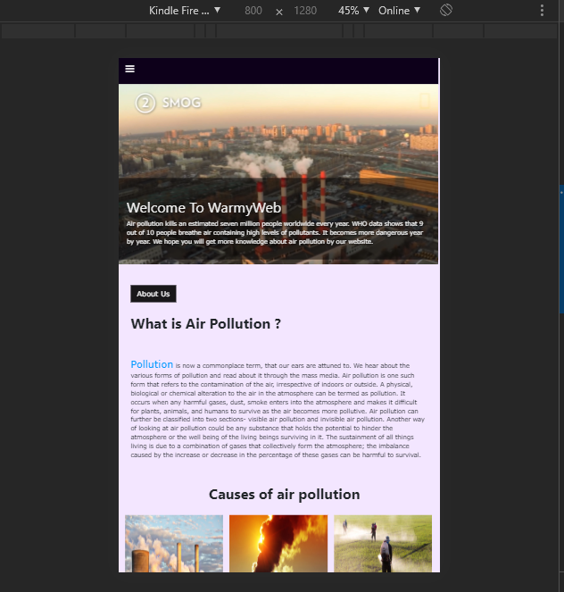 **Fig (2.1)** Tablet size testing width Kindle Fire HDX.

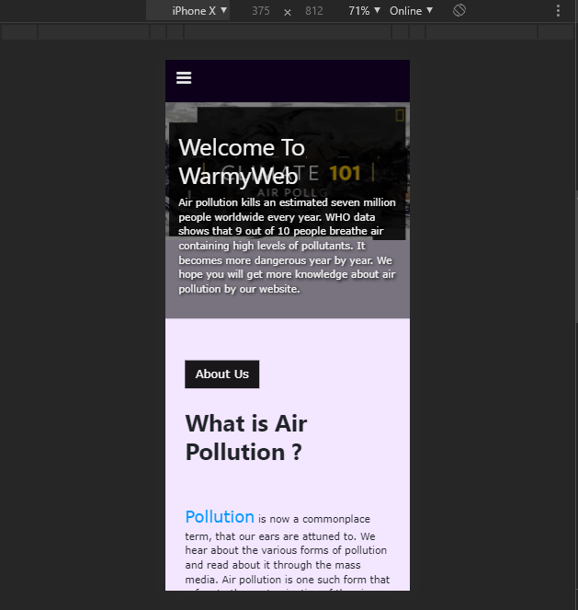

**Fig (2.2)** Phone size testing width iPhone X.

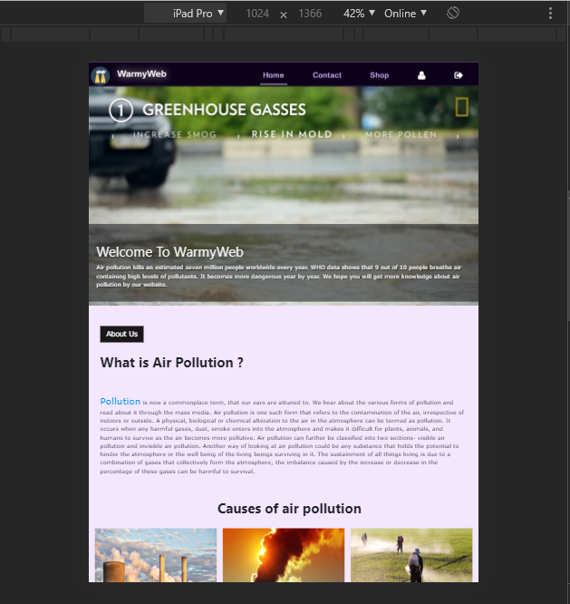

**Fig (2.3)** Testing with iPad Pro.

**Test Case 3**

|  |  |
| --- | --- |
| Test objective | To test if the website has suitable use of web service. |
| Test Data |  |
| Test Procedure | Go to user register page and hover over the sign up action button. |
| Expected Result | The free home pollution offer will pop up. |
| Actual Result | See Fig (3.1, 3.2, 3 .3) |

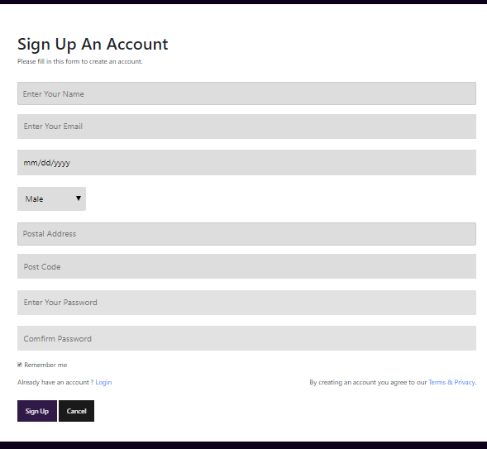

**Fig (3.1)** User register page initially.

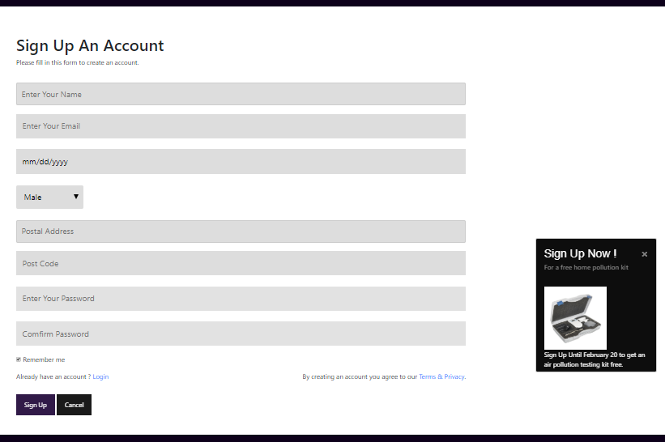

**Fig (3.2)** When user hovers on the Sign Up action button, the free home pollution testing kit is pop up.

**Test Case 4**

|  |  |
| --- | --- |
| Test objective | To test if the website personalizes the content by adding city name. |
| Test Data |  |
| Test Procedure | Go to contact page. |
| Expected Result | The Map locating the organization is shown. |
| Actual Result | See Fig (4.1) |

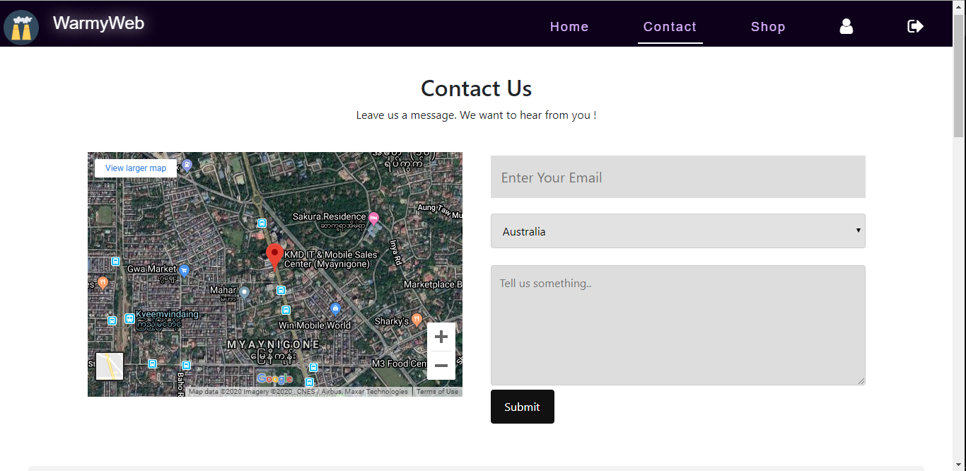 **Fig (4.1)** The map of the organization is embedded in the page.

**Test Case 5**

|  |  |
| --- | --- |
| Test objective | To test if the website has suitable use of web service by displaying purchase history. |
| Test Data |  |
| Test Procedure | Go to profile page and check purchase history. |
| Expected Result | All the purchase history of user is shown. |
| Actual Result | See Fig (5.1) |

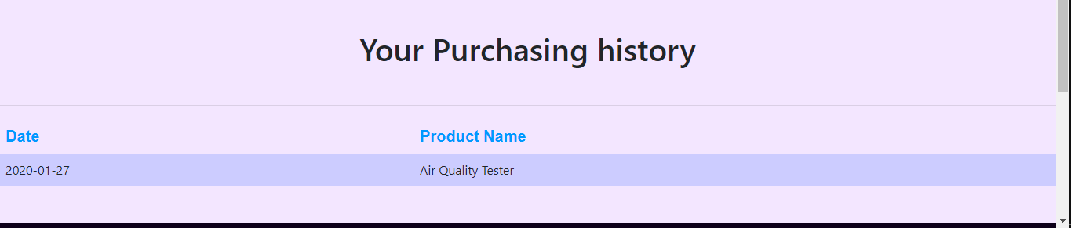

**Fig (5.1)** User’s purchase history is shown together with purchase date.

# Task 5

## **Analysis**

Task 5 is to ensure users can create and view their browsing data. Users of the website must be able to create browsing data review that data and make process on their data.

## **Assumption**

The browsing data of users are recorded every times they open a webpage like user profile, main page, shop and so on. User can access to their history page through profile page. In the history page, all the webpage names users have accessed together with date. Users can delete all the history.

**Screen Design**

**browsehistory.php**

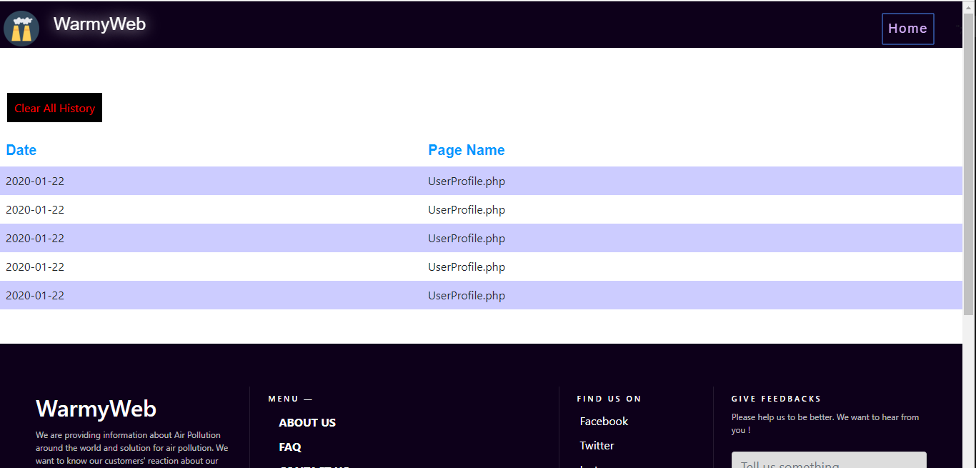

**Coding**

<?php

session_start();

$connect = mysqli_connect("localhost", "root","", "airpollutiondb");

if (isset($_GET['action']))

{

$userid = $_SESSION['id'];

$delete = "DELETE FROM `history` WHERE userid = '$userid'";

$run = mysqli_query($connect, $delete);

if ($run)

{

echo

"

<script> alert('All history cleared !');

window.location.assign('browsehistory.php');

</script>

"; }

else {

echo mysqli_error($connect);} }

?>

<a href="browsehistory.php?action='delete'" class="deletelink" >Clear All History</a><br><br>

<table width="100%" class="tbl" >

<tr>

<td><b>Date</b></td>

<td><b>Page Name</b></td>

</tr>

<?php

$userid = $_SESSION['id'];

$select = "SELECT * FROM `history` WHERE userid = '$userid' ";

$run = mysqli_query($connect, $select);

$count = mysqli_num_rows($run);

for ($i=0; $i < $count; $i++)

{

$row = mysqli_fetch_array($run);

echo "

<tr>

<td>".$row['historydate']."</td>

<td>".$row['PageName']."</td>

</tr>";

} ?></table>

**Testing**

**Test Case 1**

|  |  |
| --- | --- |
| Test objective | To test if the history page is reached when user clicks on the link at the top of profile page |
| Test Data |  |
| Test Procedure | Go to user profile page and click on the history link at the top of webpage. |
| Expected Result | The history page will be reached. |
| Actual Result | See Fig (1.1, 1.2, 1.3) |

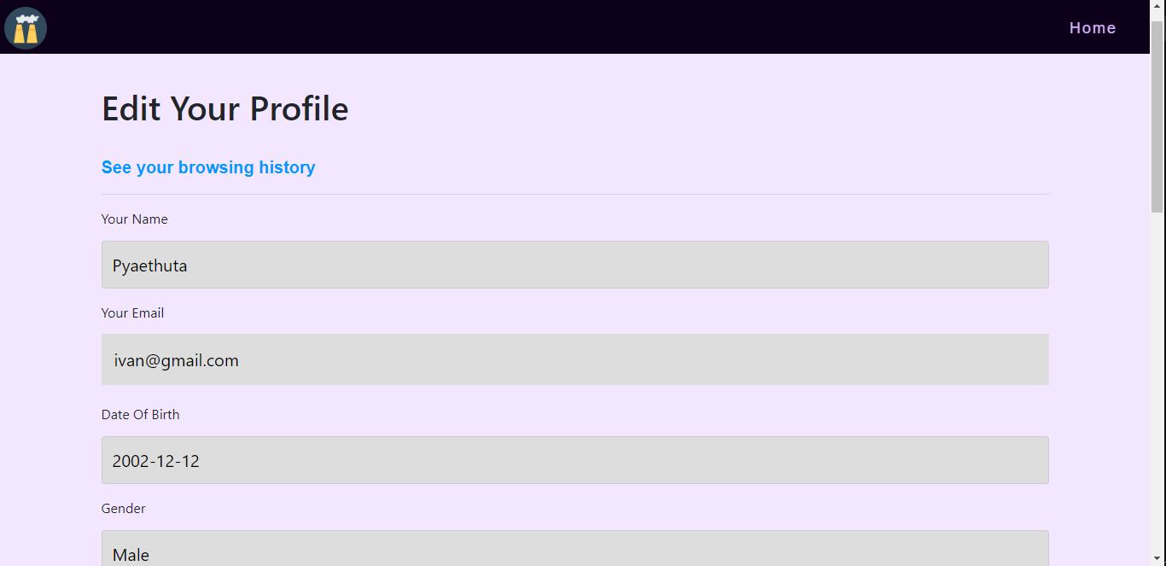

**Fig (1.1)**

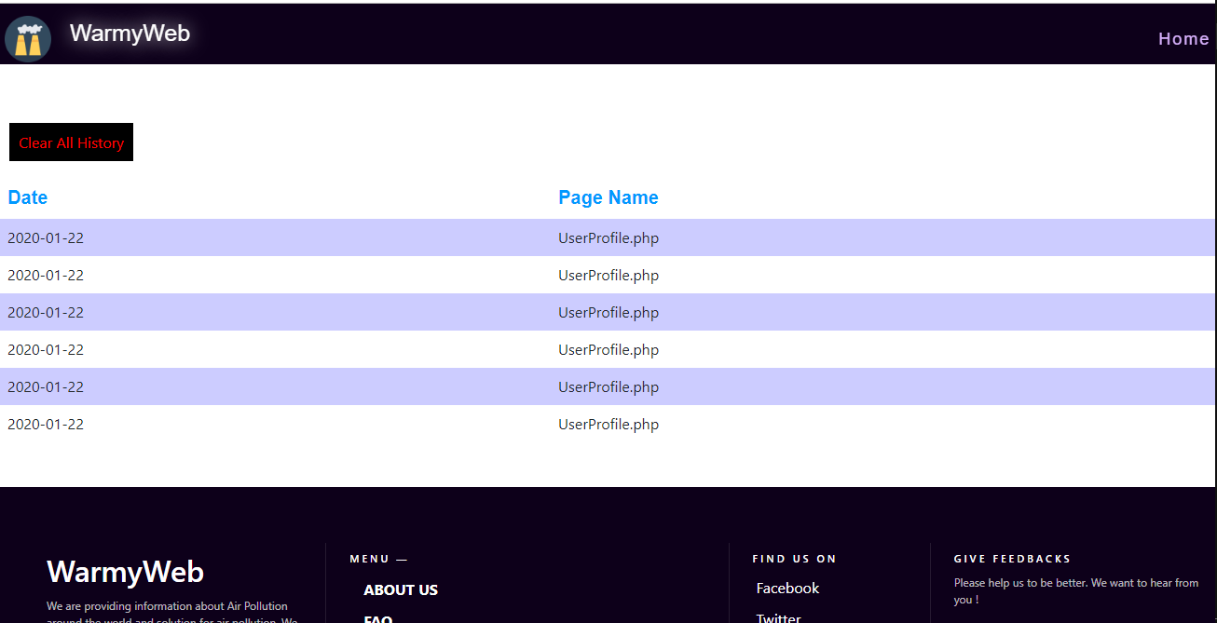

**Fig (1.2)**

**Test Case 2**

|  |  |
| --- | --- |
| Test objective | To test if the all the history is deleted when user click on the delete action button. |
| Test Data |  |
| Test Procedure | Go to history page and click delete action button. |
| Expected Result | The success message box will be shown and the browsing history is deleted. |
| Actual Result | See Fig (2.1, 2.2, 2.3) |

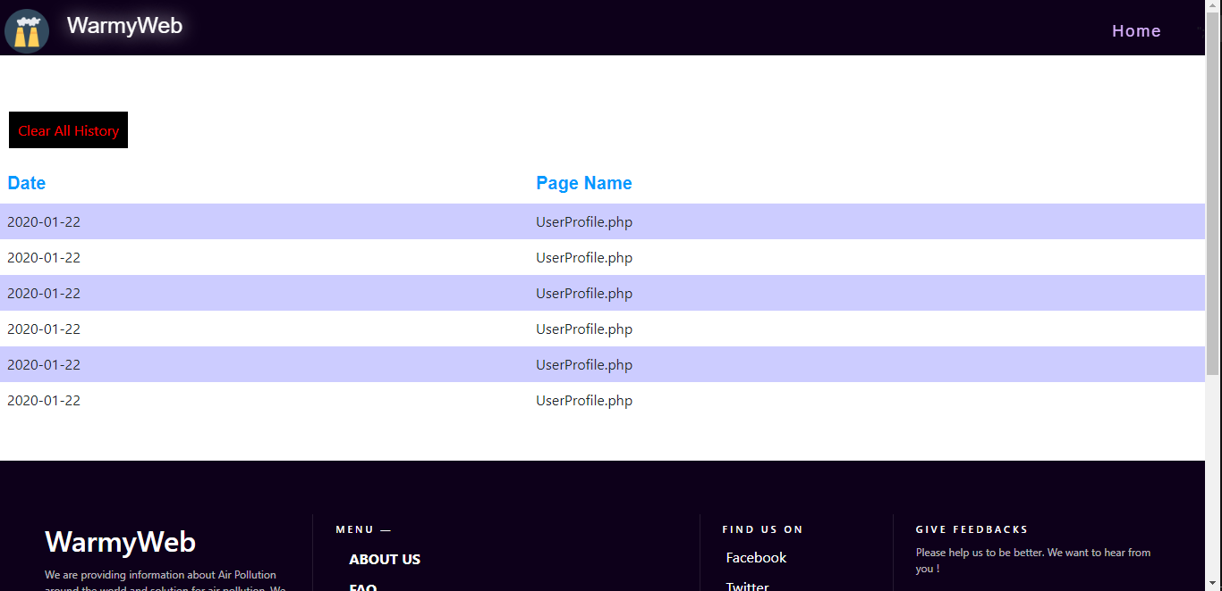

**Fig (2.1)**

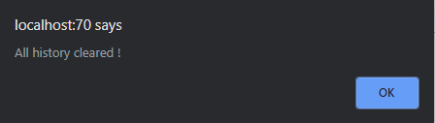

**Fig (2.2)**

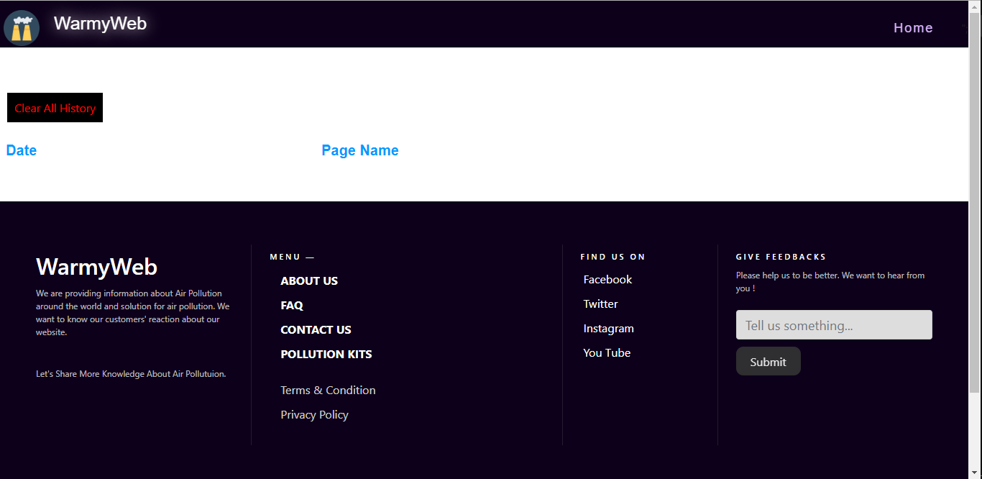

**Fig (2.3)**

# Task 6

## **Evaluation**

Rolfe, G., Freshwater, D. and Jasper, M.(2001) model is a kind of reflective writing model. It is simply based on three questions: What? So what? Now what? (Reflective Writing, 2020) The following report is a reflection critically reviewed the learning that have been undertaken to complete this assignment by using this model.

**What?**

As a developer, a dynamic website about air pollution is asked to be developed. This website should friendly to. Users must be able to create and browse with their individual accounts. It must have a great attraction to users containing images and links. Being a dynamic website, it is necessary to be expert in PHP language. Moreover, SQL and JavaScript should also be understood to develop this website for design and animation. Before getting into start, a brief information about air pollution is needed to be know. It is not difficult since there are many air pollution websites. The tasks are very interesting since the tasks ask to create the website functions as others common trending websites. Firstly, the images about the air pollution are collects first. Then, the design and color for the website is chosen and implemented. Each task has reports about analysis and assumptions. So, it is necessary to have a good writing skill of reports.

**So what?**

Being learnt much about php, the tasks are not too difficult. There is not so much issues during tasks, but JavaScript means a bit difficulty because of the less knowledge about JavaScript. So, JavaScript is learnt first since some tasks need JavaScript for design and function. Hashing password is also a difficult task. But it is solved by watching online tutorials and reading articles about protecting password. BCRYPT method is chosen for hashing password because its hashing method is strong simple to implement. CSS effects are not sometimes worked since it is used by linking. The inline CSS style is used to solve these issue. All these problems and difficulties become new experience. The new knowledge about hashing password for better security measure is got. It is pleasurable to learn about limiting log in with three attempts. Since the website is developed for a real organization, the great practical experience is got.

**Now What?**

Having reflected on the tasks, a successful outcome is resulted finally. As a dynamic website, its function can be said to successful. But it should be better with JavaScript animations. So, JavaScript is needed to learn for future improvement. The report writing skill should also be improved.

# References

*Reflective Writing*. (2020, January 25). Retrieved from LearningAdvice: https://www.op.ac.nz/assets/LearningAdvice/d0a1fac268/Reflective-writing.pdf

# Candidate Checklist

Please use the following checklist to ensure that your work is ready for submission.

Have you read the NCC Education documents 'What is Academic Misconduct? Guidance for Candidates' and 'Avoiding Plagiarism and Collusion: Guidance for Candidates' and ensured that you have acknowledge all the sources that you have used in your work?





Have you completed the 'Statement and Confirmation of Own Work' form and attached it to your assignment? You must do this.



Have you ensured that your work has not gone over or under the recommended word count by more than 10%?



Have you ensured that your work does not contain viruses and can be run directly?